Final Report

Dish Discovery -Web Based Major Project 2024

By Ryan Jones (ryj7)

Student Number: 210056622

Department Of Computer Science

Aberystwyth University

Wales

May 2018

Degree: BCs Business Information Technology (G500)

Module: CS39930

Supervisor: Dr Edel Sherratt

# Contents

Contents 2

1 Acknowledgements 8

2 Abstract 9

3 Introduction 10

4 Approach 10

5 Analysis 11

5.1 Stakeholders 11

5.2 Typical Users 12

5.2.1 User 1 – Lucia, 22 (Client) 12

5.2.2 User 2 – Bill, 39 13

5.2.3 User 3 – Greg, 32 14

5.2.4 User 4 – Margret, 57 14

5.3 Use Case Diagram 15

5.4 Use Cases and Navigation 15

5.4.1 Log in/ Create Account 15

5.4.2 Edit Recipe 16

5.4.3 Add Recipe 16

5.4.4 Remove Recipe 17

5.4.5 Make Shopping List 17

5.4.6 Remove From Planner 18

5.4.7 Add To Planner 18

5.4.8 Log Out 19

5.4.9 Browse Recipes 19

5.4.10 Change User Password (Admin And Regular User) 20

5.4.11 View Recipe 20

5.5 Related Materials 21

5.5.1 BBC Food 21

5.5.2 Simply Recipes And Relish 24

5.5.3 Allrecipes 27

6 Design 30

6.1 Website Structure 30

6.1.1 Landing Page 30

6.1.2 Login Page 31

6.1.3 Home Page 32

6.1.4 Admin Page 33

6.1.5 My Recipes page 34

6.1.6 Selected Recipe Page 35

6.1.7 Shopping List Page 37

6.1.8 Account Page 38

6.1.9 Edit Recipe page 39

6.1.10 Recipes Page 41

6.1.11 New Recipe Page 42

6.1.12 Help Page 43

6.2 Evaluation 44

6.3 Persistent Data Model 49

6.4 Tables and Data 49

6.4.1 Users Table 49

6.4.2 Recipes Table 50

6.4.3 Planners Table 50

6.4.4 Front End Test Data 51

7 Implementation 52

7.1 Development Schedule 52

7.2 Frameworks And Tools 52

7.3 Issues Faced 53

7.4 Persistent Data Management 56

8 Achievements 56

8.1 Improved Skills 56

8.2 What Went Well 56

8.3 Site Breakdown 56

8.3.1 Landing Page 56

8.3.2 Login Page 57

8.3.3 Planner Page 57

8.3.4 Recipes Page 58

8.3.5 My Recipes Page 58

8.3.6 Shopping List Page 59

8.3.7 Help Page 60

8.3.8 My Account Page 60

8.3.9 Selected recipe Page 61

8.3.10 Add Recipe Page 62

8.3.11 Edit Recipe Page 62

8.3.12 Administrator Page 63

9 Testing 64

9.1 Test Table 64

9.2 User Testing And Feedback 69

10 Critical Evaluation 71

10.1 The Design 71

10.2 Choice Of Tools Used 72

10.3 What I Would Do Differently 72

10.4 Future Development 73

11 References 74

13 Appendices 77

13.1 Appendix A – Design Questionnaire 77

13.2 Appendix B – Test Table Images 83

13.3 Appendix C – Original Prototype 89

13.4 Appendix D – Ethical Clearance Confirmation 95

List Of Figures

Figure 1. Waterfall development methodology. 11

Figure 2. Project Gantt Chart. 11

Figure 3. Rich picture of the environment that the system will be working in. 12

Figure 4. This is the use case diagram of the actions that the user will be able to carry out. 15

Figure 5. Login/Create Account 16

Figure 6. Edit Recipe. 16

Figure 7. Add Recipe. 17

Figure 8. Remove Recipe. 17

Figure 9. Make Shopping List. 18

Figure 10. Remove From Planner. 18

Figure 11. Add To Planner. 19

Figure 12. Log Out. 19

Figure 13. Browse recipes. 20

Figure 14. Change Password. 20

Figure 15. View Recipe. 21

Figure 16. These are the navigation tabs that are well labelled to ensure that the user knows what they are clicking on. 22

Figure 17. BBC Food recipe. 22

Figure 18. Screenshot of the shopping list created when selecting the shopping list button. 23

Figure 19. Example of recipes that have been added to the favourite items page. 23

Figure 20. A screenshot of the home page of simply recipes. 24

Figure 21. The recipes are not boxed in a uniform way and take up a large portion of the screen on some devices. 25

Figure 22. Relish navigation bar to see the functions of the site. 26

Figure 23. Relish shopping list. 26

Figure 24. Relish recipes. 27

Figure 25. Allrecipes nutritional information page for a recipe. 28

Figure 26. A screenshot of the videos that are playable on the site. 29

Figure 27. The different things the user can do with a recipe. 29

Figure 28. Structure and navigation of the site. 30

Figure 29. Landing page view. 31

Figure 30. Login page view. 32

Figure 31. Home page view. 33

Figure 32. Admin page view. 34

Figure 33. My Recipes page view. 35

Figure 34. View Recipe page view. 36

Figure 35. View Recipe page view. 36

Figure 36. Select day for recipe view. 37

Figure 37. Shopping list page view. 38

Figure 38. Account page view. 39

Figure 39. Edit recipe page view. 40

Figure 40. Edit recipe page view. 40

Figure 41. Recipes page view. 41

Figure 42. Add recipe page view. 42

Figure 43. Add recipe page view. 43

Figure 44. Graph to show how easy users found it to find the login/register option. 44

Figure 45. Graph to show how easy users found it to access the site by logging in/registering. 45

Figure 46. Navigation diagram to get to a selected recipe. 46

Figure 47. chart for how easy it is to find a recipe. 46

Figure 48. Chart for how easy it is to follow the recipe. 46

Figure 49. Navigation diagram to get to the shopping list. 47

Figure 50. Chart to show the difficulty of viewing the shopping list. 47

Figure 51. Chart to show difficulty of following the shopping list. 48

Figure 52. Chart to show the difficulty of creating a recipe. 48

Figure 53. Diagram of the tables in the database and how they link. 49

Figure 54. Query to create the users table. 50

Figure 55. Users table with two example users. 50

Figure 56. Query to create recipes table. 50

Figure 57. Recipe table with an example recipe. 50

Figure 58. Query to create the planner table. 51

Figure 59. Full table of the recipe IDs in the planner. 51

Figure 60. JSON of an example recipe. 52

Figure 61. Release table. 52

Figure 62. Code for saving an image. 53

Figure 63. Image file validation. 54

Figure 64. Code to clear any uses of the recipe that is being deleted. 54

Figure 65. Example of how if the response is successful, it will redirect the site, else it will display the message. 55

Figure 66. Small statement that shows how the site is redirected or how a message is passed to the JS file. 55

Figure 67. Landing page. 57

Figure 68. Login/register page. 57

Figure 69. Planner page. 58

Figure 70. Recipes page. 58

Figure 71. My recipes page. 59

Figure 72. Shopping list page. 59

Figure 73. Help page. 60

Figure 74. My account page. 61

Figure 75. Selected recipe page 1. 61

Figure 76. Selected recipe page 2. 62

Figure 77. Add recipe page. 62

Figure 78. Edit recipe page. 63

Figure 79. Admin page. 63

# Acknowledgements

I would like to thank the Computer Science department for teaching me all the skills I needed to complete this project and have a successful career in this industry, and my friends and family for being very supportive throughout my time at Aberystwyth University. I would like to especially thank Dr Edel Sherratt for her support and guidance when working on this project.

# Abstract

For this project I have created a site for friends and family to use to create and share recipes that can be added to a planner and provide a simple list of all ingredients that can be used as a shopping list. To start this project a business analysis was carried out to find out what the users would need. This includes browsing and searching recipes as well as being able to add to the ever growing number of recipes.

After getting a good idea of who I was making the site for and the use cases that would be needed, a UI design and evaluation was carried out where the first prototype was made and was given feedback by a range of potential users to add in later prototypes and the final product. The next step was the technical design, which focused on the site structure and outline what each page was for. This would also show what tables and data would be needed for the persistent data that is needed for the site. The completion of these documents aided in setting up a plan of the order of how use cases would be implemented.

Dish discovery successfully met the criteria of fulfilling all of the use cases and was built using HMTL and CSS with the help of Bootstrap for the view of the site (View), JavaScript and jQuery for some of the font end functionality (Controller) and PHP and a PostgreSQL database to manipulate and store the data in the site (Model). Testing was carried out manually by myself as well as having some of the users from the prototype feedback testing the site.

**Word Count:**

# Introduction

The web-based project that I decided to build was a meal planner that allows the user to look through recipes created by themselves and their close friends and family to add to this planner. There are options to create a shopping list from the recipes selected in the weekly planner.

The customers/users of this site are my close friends and family to allow them to share recipes efficiently and in a clear format as well as making them easily accessible. The customer also wanted to ensure that meal planning and shopping trips are efficient.

The people that wanted this site to be built were the users/customers as it is for people who are interested in cooking as well as wanting to share the recipes with their friends.

# Approach

When working on this project, I found it important to plan each section of the project. To get a good idea of who the users were and what they needed, I first did a business analysis to understand what the users would need from the site as well as evaluating other similar sites to see how I could combine and improve some of the elements from those sites.

After the business analysis, a UI design and evaluation was carried out to get an idea of what this site would look like. Once a final design was agreed upon, a technical design was completed to show how pages would be linked and how the data would be passed and displayed on the site.

The development methodology used to plan and develop this site was the waterfall development methodology (McGuire, 2024)(Figure 1). The reason for this sort of development was that it was the methodology that followed the course of the deadlines in the best way, and it seemed the most appropriate for the shorter timeframe given.

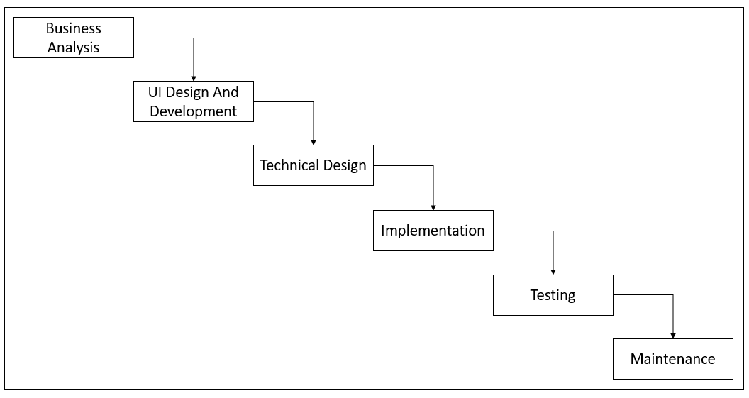

Figure 1. Waterfall development methodology.

The Gantt chart in Figure 2 shows when each section of the project was completed. The Gantt chart is very similar to how the waterfall methodology is laid out with each section being completed one step at a time. The report part covers the testing and maintenance as it has information on test results and how the site can be maintained in the future as well as future plans. Further information about the site setup can be found in the DBSETUP.md file in the Gitlab repository.

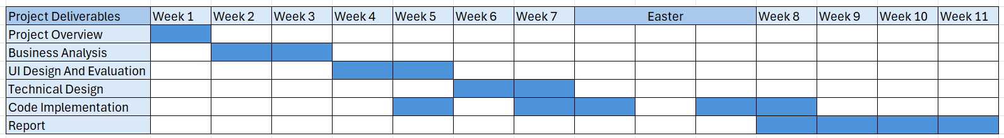

Figure 2. Project Gantt Chart.

# Analysis

The analysis section is based off the business analysis that was completed before the implementation stage. It was created to get an idea of the potential users and the use cases that the site needed to fulfil the needs of the users. A number of typical users were created to realistically see what they could use the site for as well as comparing the site to other similar sites.

## Stakeholders

The rich picture below shows the different interactions that the website has when it is used (Figure 3). It covers each of the functions of the site as well as the external factors such as getting the food and the power to houses that the users live in. 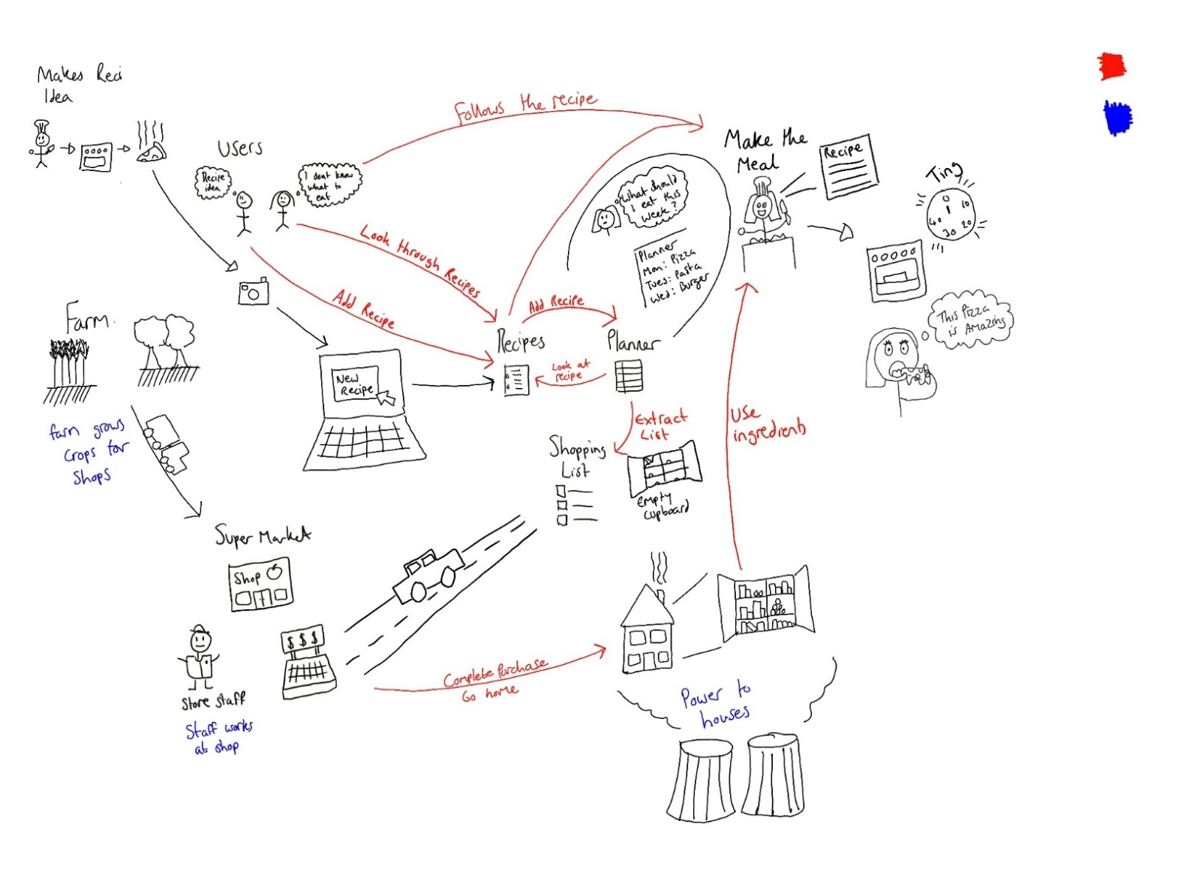

Figure 3. Rich picture of the environment that the system will be working in.

Figure 3 shows the two possible users of the site. These types of users can be the same person that wants to add their own recipes and add them to their meal planner. These users can create recipes, then select the recipes and then add them to their planner.

The recipes are all stored in a table that can be added to a planner table that stores up to seven recipes (the seven days of a week). If there are any recipes in the planner, a shopping list can be made which gets all of the ingredients from the recipes in the planner and puts them in a large list.

## Typical Users

The typical users are what the potential users could be like and it outlines some of their habits when planning their meals and how the site could help them.

### User 1 – Lucia, 22 (Client)

Lucia is 22 years old and is a university student that likes to share pictures of the food she makes and how to make them with her family. She also likes to make a plan of what she would like to have for dinner that week so she knows what to buy to try and save money and waste less food. Many of the meals she makes are ones that she has been taught to make by her mum but she sometimes forgets some of the steps.

**Interview With Client**

Do you plan your meals on a weekly basis? If so, how do you plan them and what tools do you use?

*Yes, I plan my meals using the notes on my phone and by checking what ingredients I already have.*

Do you write a list before you go shopping? If so, where do you write the list?

*I do write a list, on my notes app.*

Do you share recipes with friends and family? If so, how do you share them?

*Me and my family normally share recipes by sending the websites where we found them to each other.*

If there was a way to share recipes with your friends and family online, what things would you expect to see or would want to see on it?

*It would be good to have all the recipes in one place, either a website or app so they are easy to find. It would be interesting to be able to know what our friends or family have tried to make.*

*Also, it would be good to have a list of the ingredients needed in a way that would be easy to add them to our shopping lists.*

**How The Site Will Help…**

To help with some of the meal planning the site can help store recipes that she creates and if her friends and family have an account, they will also be able to see these recipes. To help with shopping, the site uses the recipes in the planner to create a shopping list of all the ingredients needed.

### User 2 – Bill, 39

Bill is 39 years old and is part of a healthy eating group where they share their newly found healthy recipes with each other to try. It is fairly easy for Bill to share his recipes as he writes them down and passes them on to the people he wants to share them with. Bill also likes to bake and enjoys trying to recreate takeaways at home.

The site can help Bill by using Dish Delivery as a platform to share his healthy recipes with his friends in the group. The planner function of the site makes it easier to keep track of what Bill wants eat for the week such as the takeaways he wants to recreate.

### User 3 – Greg, 32

Greg is 32 years old and likes to plan his meals and make his shopping trips as efficient as possible as he is very busy on weekdays and likes to spend his weekends away with his dog. Greg uses the built in notes app on his phone and has to think about the meals and the ingredients needed to make the meals before he goes shopping which can take up a large amount of time.

The site can help Greg to plan his meals in advance and create a list for his shopping trip. The ability to remove meals from his planner or leaving the weekends blank means that he doesn’t need to have something for each day of the week if he is away.

### User 4 – Margret, 57

Margret is 57 years old and loves to cook. She likes to share recipes she’s made with friends on WhatsApp but the recipes get lost in the chat as people send messages. Margret also keeps some of her older recipes in a book that is almost full and has had liquids spilled on it many times meaning some of the recipes are lost and thinks that if she could access them all from her tablet or phone it would make her life a lot easier.

Like the other typical users, Margret likes to share her recipes with friends. Instead of keeping all of the recipes in a WhatsApp chat, she can store them all on the site as well as getting her friends to sign up too to be able to access their recipes they like to share with each other whenever they want. The site is also responsive to be able to be used on devices with smaller screens.

## Use Case Diagram

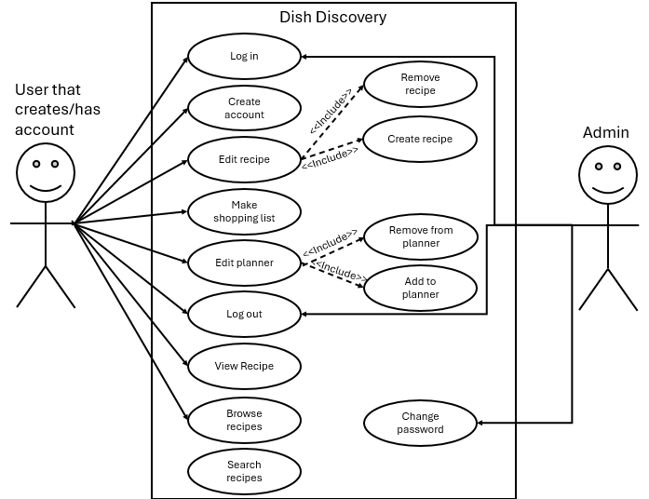

Figure 4. This is the use case diagram of the actions that the user will be able to carry out.

Figure 4 is a use case diagram for the typical user and all the functions they are able to complete. There is only one actor that is a normal user because users are only allowed to use the page once they are signed in. The aim is to keep the recipes private in the close community that is formed in the site. Each normal user can access the same content. The admin actor is used to change passwords if needed. They will only have access to one page which displays user data.

## Use Cases and Navigation

The structure of the site is based on what functions would be most important such as viewing recipes whether they are created by the logged in user or another user. The outlined use cases below have a description of what they do and a small diagram to show how users can get to them to carry out this function.

### Log in/ Create Account

To access the site, both the admin and regular users must log in to view the pages they need. Administrators cannot create an account as this is used to manage current users. To create an admin account, a script needs to be ran to create it. For a regular user to create an account, a key is needed which is supposed to be shared by current users to avoid others who do not have a key creating an account.

To log in, both users have to use the landing page and then navigate to the login/register page. From here they are able to create an account or log in by filling in the forms provided.

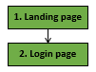

Figure 5. Login/Create Account

### Edit Recipe

To edit a recipe the user has to navigate to “My Recipes” to be able to see a list of their recipes in order to edit them. Users are only allowed to edit their own recipes. This involves adding recipes and removing them if needed.

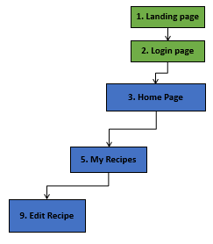

Figure 6. Edit Recipe.

### Add Recipe

Users are able to create recipes of their own that will be seen by other users. To add a recipe users can use the “My Recipes” page and use the “+” button to create a new recipe. From there they can fill in the form to create a new recipe. When this form is completed, the confirm button can be pressed to add the recipe to the recipes table and will be displayed on the recipes page for all users to see.

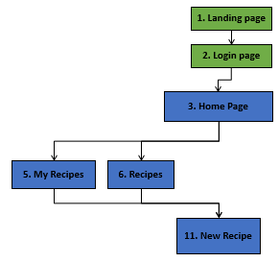

Figure 7. Add Recipe.

### Remove Recipe

Like with editing recipes, users can only delete recipes they have made so they will have to go through the “My Recipes” page to delete their recipes. A button next to the recipe they want to delete can be clicked to delete the recipe permanently.

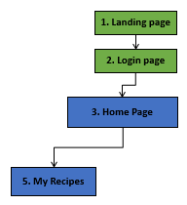

Figure 8. Remove Recipe.

### Make Shopping List

To “make” the shopping list users need to have something in their planner otherwise their shopping list will be empty. The list is generated automatically from the planner table. As long as the shopping list is open without refreshing the page, users can cross off the items in the list with a press of a button. Another button is also displayed that can be used to temporarily remove the item off the list. This can be returned by refreshing the page.

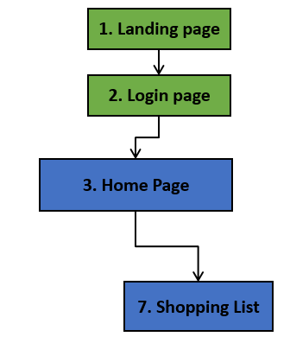

Figure 9. Make Shopping List.

### Remove From Planner

Users are able to remove meals from their planner. To remove from the planner users need to get to the home page where the planner is. There are buttons next to the items on the planner to remove recipes if the user doesn’t need to make a meal that day.

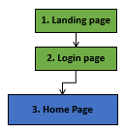

Figure 10. Remove From Planner.

### Add To Planner

To add to the planner users need to go to a selected recipe and use the dropdown menu to select which day they want to put the recipe into. When a recipe is added to the planner it will be displayed on their home page where they can view the recipe from there if needed by clicking on the recipe name.

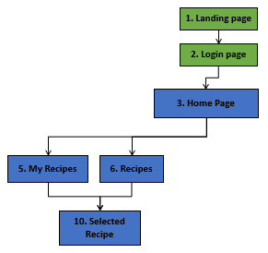

Figure 11. Add To Planner.

### Log Out

To log out, a regular user has to go to the account page and press the log out button. This will immediately log out the user and return them to the login page. For an admin to log out they can also log out from their account page or click on the log-out tab in the navigation bar.

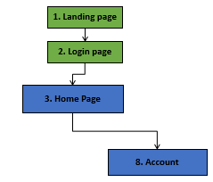

Figure 12. Log Out.

### Browse Recipes

To browse recipes users need to navigate to the “recipes” page where they will see all recipes as well as a search bar to search by recipe name and by user.

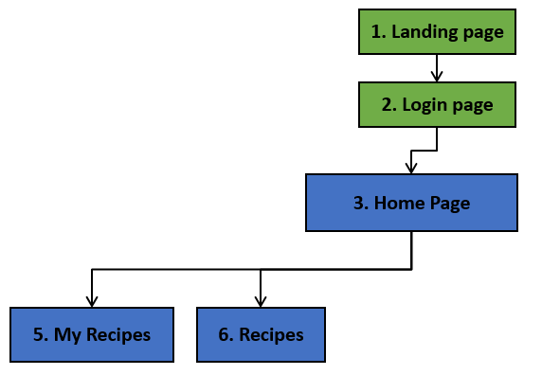

Figure 13. Browse recipes.

### Change User Password (Admin And Regular User)

To change a password, users have to go to the “account” page and change their password and confirm their choice. Admins can change user passwords in the admin page. The admin page displays all users and a text box to change the password. Admins are unable to see the current password to protect the user’s account so they are only able to reset them and it is advised that users should change their password as soon as they can get on to their account.

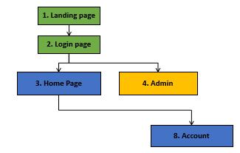

Figure 14. Change Password.

### View Recipe

To view a recipe, users need to navigate to one of the two recipe pages or their planner and then select the recipe they want to view. When on the selected recipe page, they can see their desired recipe.

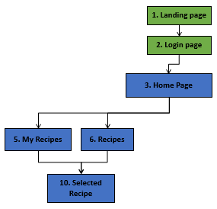

Figure 15. View Recipe.

## Related Materials

When evaluating other sites that provide a similar service, it was important to have a criteria to assess each one to see what they provide and how they could be improved. The following criteria was used to assess some of the most popular recipe sites. The following criteria was used:

* Ease of use
* Responsiveness
* Recipe view
* Shopping list
* Saving recipes

### BBC Food

Some sites are similar to this project: including the BBC Food that contains many recipes as well as a button that displays a shopping list (BBC, 2024). What makes this site different from this project is that there will be options for users to add their recipes and share them with the few users of this site.

**Ease Of Use**

The site is easy to follow and is very informative when it comes to giving the user the information they need (Figure 16). The layout of the site means that the site and recipes are both easy to follow and are very clear when trying to provide information.



Figure 16. These are the navigation tabs that are well labelled to ensure that the user knows what they are clicking on.

**Responsiveness**

The responsiveness of this site is good as the site is still functional and everything is still very clear. The navigation bar collapses down into a burger menu that can be easily accessed on a mobile device. The text and colour of the site are both clear, making everything easy to read.

**Recipe View**

**The Recipes on BBC food are very clear and have simple step by step instructions that are very informative. This is shown in** Figure 17**.**

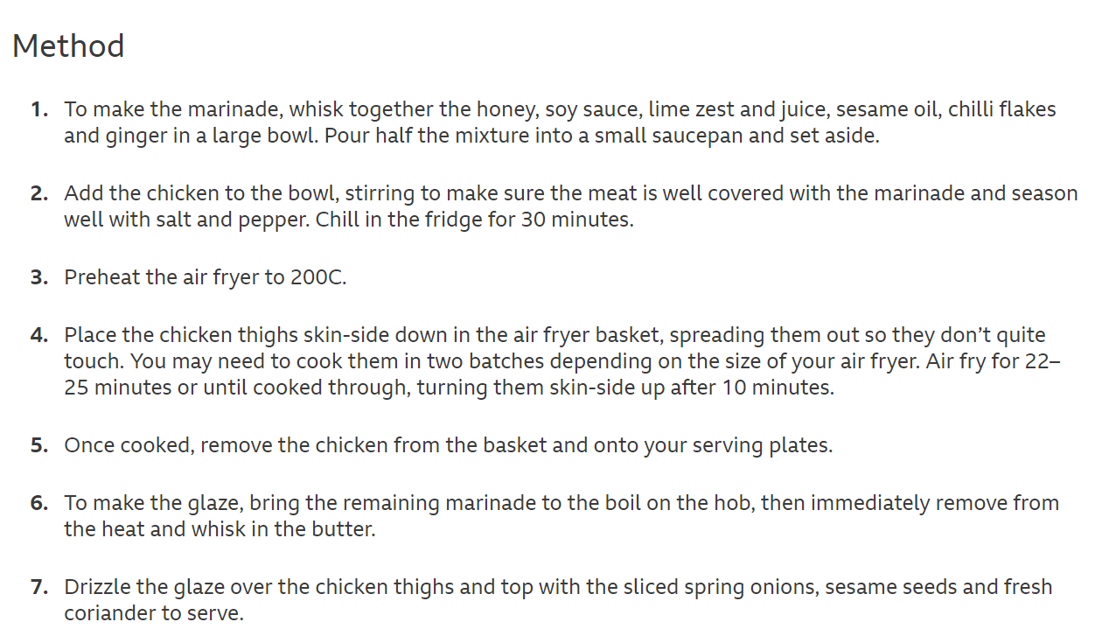

Figure 17. BBC Food recipe.

**Shopping List**

A good function of the BBC Food website is that it is possible to create a detailed shopping list that separates the ingredients into categories to make shopping trips more efficient. While there is a shopping list, it doesn't allow the user to add multiple recipes to the list so they can get all the items they need in one shop (Figure 18).

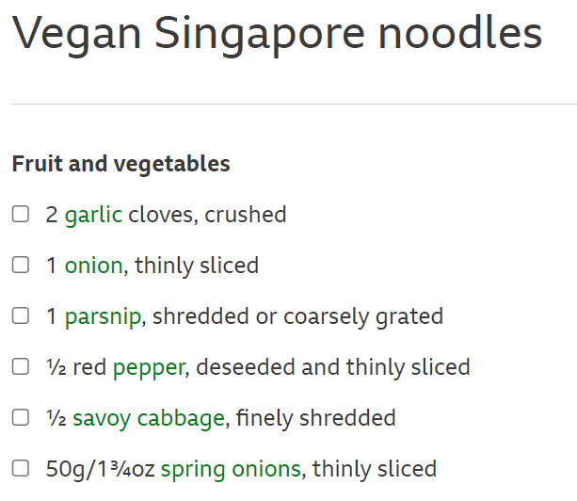

Figure 18. Screenshot of the shopping list created when selecting the shopping list button.

**Saving Recipes**

Another good thing about this site is that users are able to save recipes they like in their “favourites” to look back on later if they have an account. This is useful for a site that provides a large number of recipes (Figure 19).

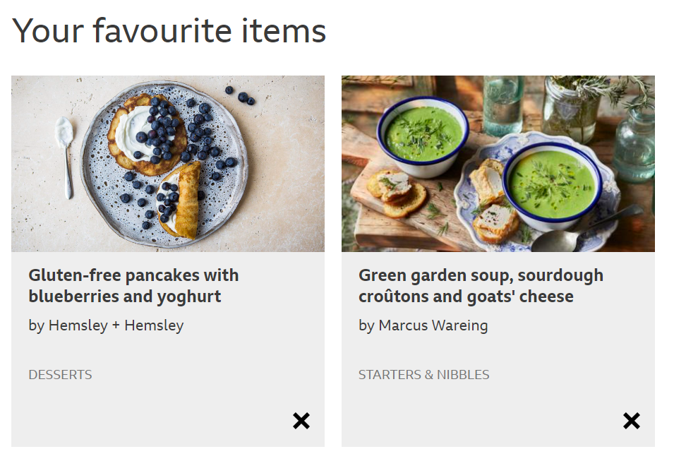

Figure 19. Example of recipes that have been added to the favourite items page.

### Simply Recipes And Relish

Another site that is similar to this project is “Simply Recipes” which provides users with a range of recipes made by verified cooks (Dotdash Meredith, 2024). They also use another site to create an online shopping list for the user called “Relish”. These sites provide a similar service to my project but require the user to use two separate sites instead of having it all in one place (Relish, 2024).

**Ease of use**

A good thing about Simply Recipes is that it looks friendly and provides a nicer atmosphere compared to BBC Food. While the site looks nicer, there are some negative things when it comes to the site layout. The recipes are not shown in a uniform way and could confuse new users when trying to find a recipe (Figure 20, Figure 21). The site also looks very busy and overwhelming.

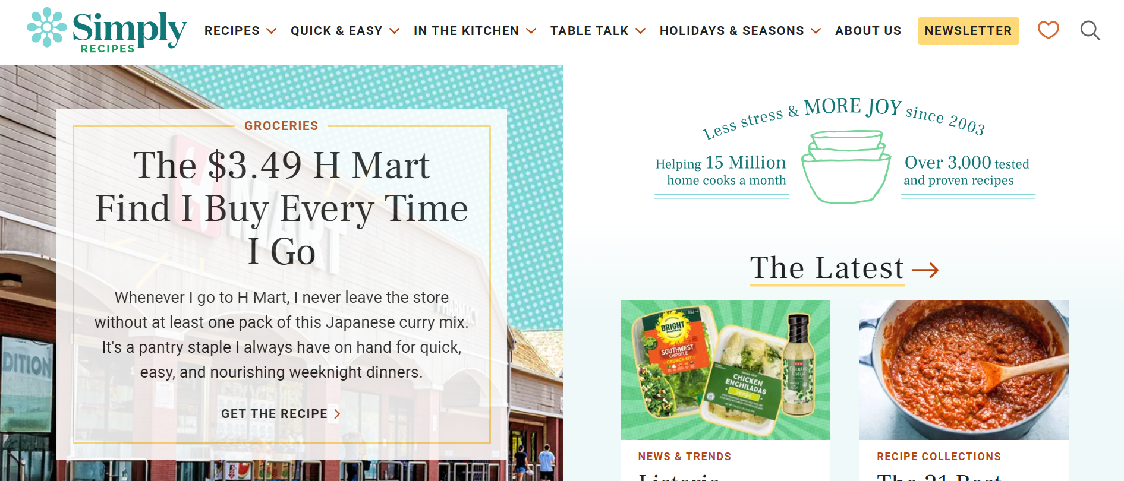

Figure 20. A screenshot of the home page of simply recipes.

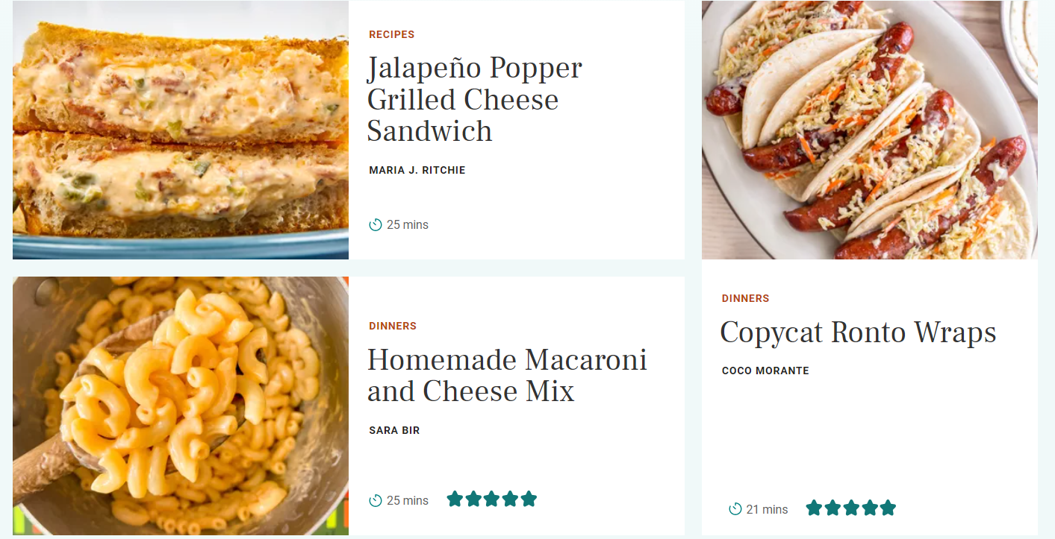

Figure 21. The recipes are not boxed in a uniform way and take up a large portion of the screen on some devices.

**Responsiveness**

This website is very user-friendly when it comes to using it on a mobile device as this site is very responsive. The site looks clearer on a mobile device as everything is in a single column meaning that it is easy to scroll through.

**Recipe view**

When looking at the recipes there is a large portion of text before the recipe which is a bit of a back story from the creator which is good but could put users off as the recipe isn’t readily available.

**Shopping list**

**Relish provides a shopping list that can have many recipes added to it to have an extensive shopping list** Figure 22**,** Figure 23**. It allows the users to check off the items on the list but does not allow the user to remove them in the case that the user already has the items.**

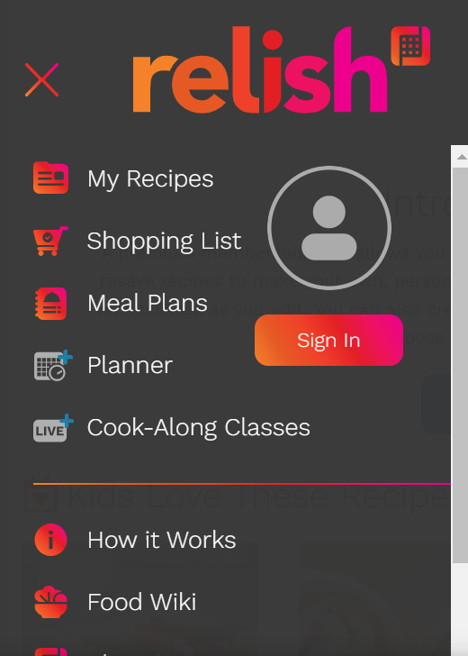

Figure 22. Relish navigation bar to see the functions of the site.

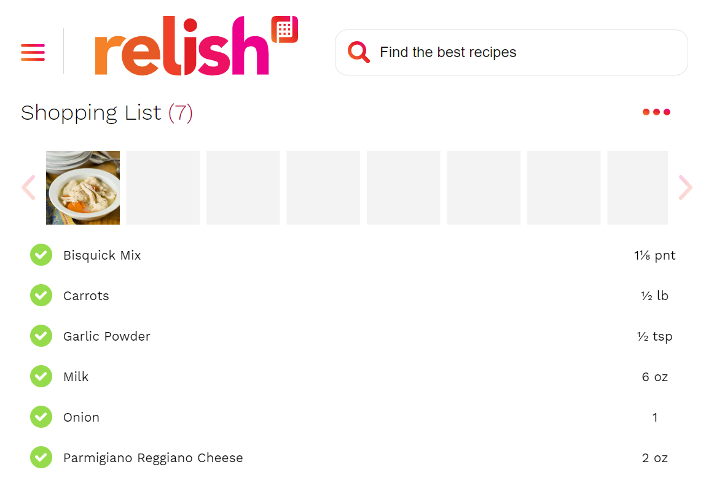

Figure 23. Relish shopping list.

**Saving recipes**

**Simply recipes uses Relish to allow users to save the recipes they find on their site. This is good as it allows for one site to just be for sharing recipes with everyone and the other to has a personal planner. The downside to this is that is that another site has to be used and it would be easier to have it all in one site with one account instead of having to sign in to both.**

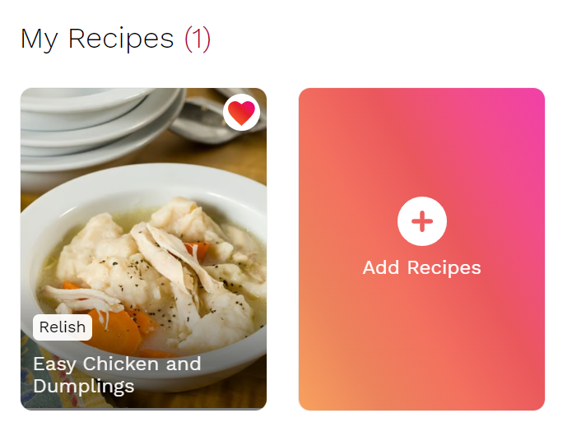

Figure 24. Relish recipes.

### Allrecipes

The final site that provides a similar service to my project is “Allrecipes”. They provide a range of recipes as well as short videos to show the user how to make the recipe with a visual aspect (Dotdash Meredith, 2024).

**Ease of use**

**The site appears to be easy to use and is straight-to-the-point with the recipes as they are easy to find and follow. They all have the ingredients, steps and pictures all in one place and in a good order without having to look too hard for the recipes. The site has an easy to follow rating system and provides good nutritional information per serving (**Figure 25**).**

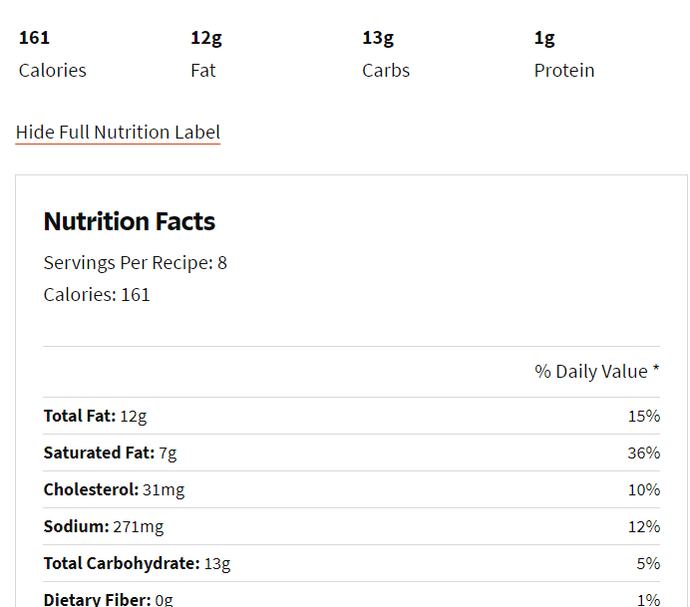

Figure 25. Allrecipes nutritional information page for a recipe.

**Responsiveness**

While this site is responsive like the other examples, there are some issues with the wrapping of text and image sizes. The banner at the top of the page does not shrink depending on screen size so some of the information is lost. The log in button also has text that wraps below on the login button. This could be better if it used a small thumbnail image or symbol to show that it is a login button. The news and trending section of the landing page has some of the text for the headlines cut off. This could be improved with the formatting of the cards they are displayed on.

**Recipe view**

A good thing about this site is that they offer more than one form of media to show off the recipe. They add the typed out recipe along with pictures and videos for users to follow to help users that find it easier to follow instructions from a video rather than reading (Figure 26).

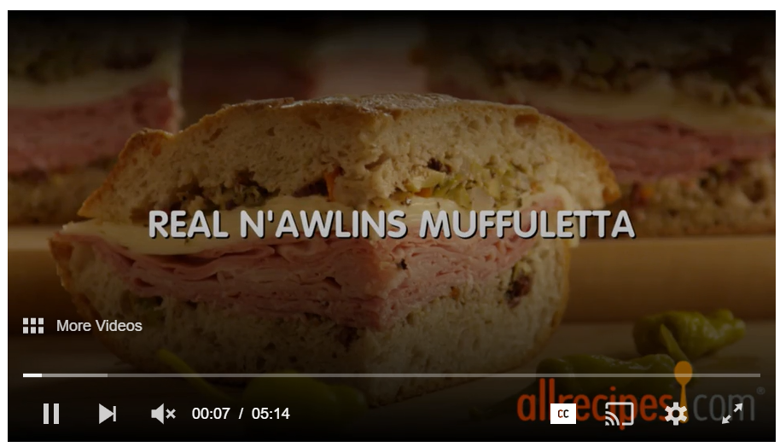

Figure 26. A screenshot of the videos that are playable on the site.

Like Simply recipes, Allrecipes has some information before the recipe that takes up a large portion of the page which could put users off as they would want access to the recipe straight away. This could be put below the recipe for users that are interested so the users that just want the recipe can access the information they need to make their meal.

**Shopping list**

**This site does not provide a shopping list feature.**

**Saving recipes**

**The site has the ability to save recipes but like the others, it requires the users to have an account (**Figure 27**).**

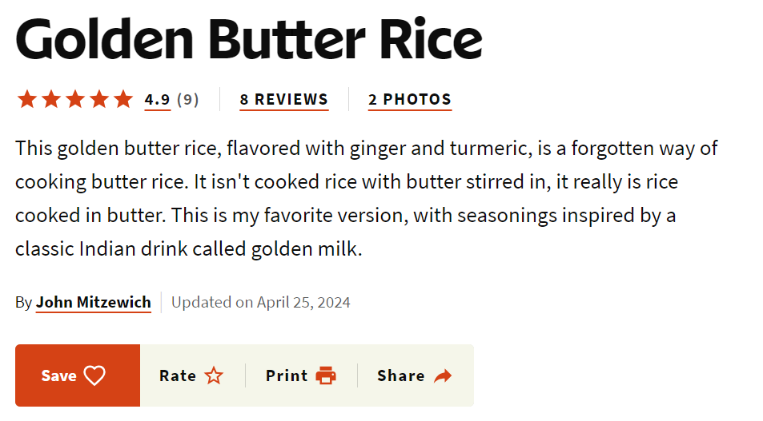

Figure 27. The different things the user can do with a recipe.

# Design

## Website Structure

Figure 28 shows the pages of the site and how they are linked along with what each of the different users can access. As the administration account is only there for managing users, they will only need to access the landing page, login page and the admin page. The admin page allows the admins to change passwords and delete users if needed. Normal users have access to almost everything on the site apart from the admin page, for security reasons. Normal users are able to carry out all of the required functions on these pages in as few clicks as possible. To allow the user to do what they want to do in as few clicks as possible, all of the important pages have been put at higher levels in the diagram with only the pages that require more user input taking longer to access.

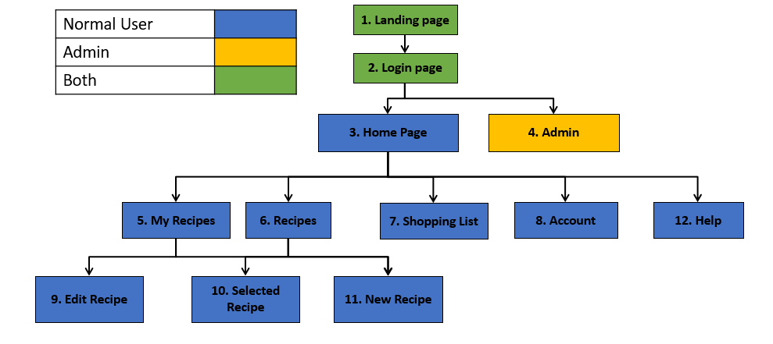

Figure 28. Structure and navigation of the site.

### Landing Page

The landing page is the first thing the user sees when loading up the site. It contains a brief description of what the site does and what the user needs to do to register (Figure 29). Everything is the same when it comes to the content when on mobile other than the navigation bar being in a burger menu to save space. There is also an in-text link to make it easier for users to get to the login/registration page as they can click on it while reading the description.

The mobile version of the site contains a burger menu to save space and to make sure that the site does not look too crowded.

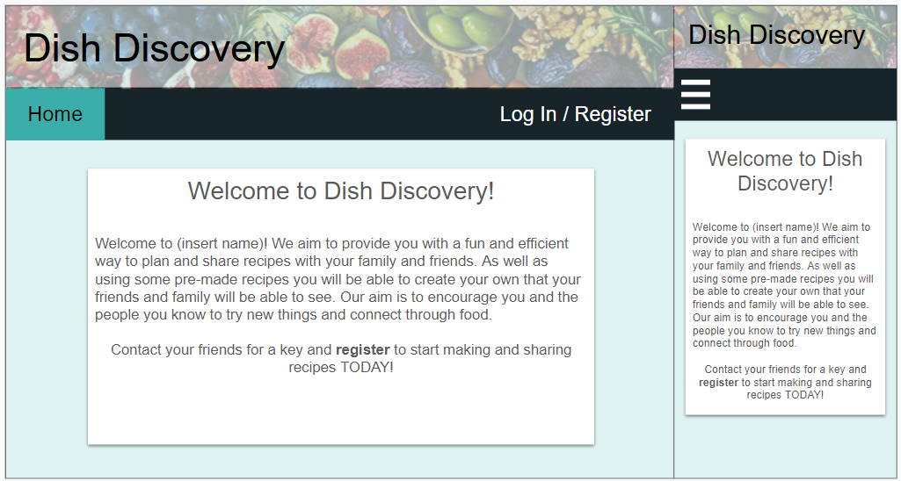

Figure 29. Landing page view.

|  |  |
| --- | --- |
| Page ID | 1. Landing Page |
| Info On Page | Shows some information about the site and how to register. |
| Page Generation Details | The page has all of its information generated in html with links to get to the login page. |
| Links To Other Pages | This page links to 2. Login Page. |
| Other Things Worth Noting | None |

### Login Page

The login page contains the forms for both logging in and registering as number of users is limited to whoever has access to the key (Figure 30). This is a closed system to be used by a small number of close friends and family members. The key is given out by current users. The forms are clearly separated with large headers to make sure the users knows what form to fill in.

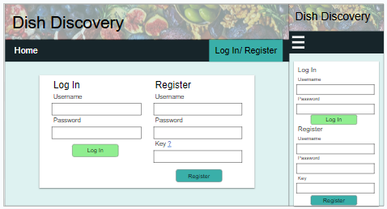

Figure 30. Login page view.

|  |  |
| --- | --- |
| Page ID | 2. Login Page |
| Info On Page | This page has a form for logging in and registering. |
| Page Generation Details | The page uses html form elements to generate the forms. Once the data is filled in, it is checked with form validation in JavaScript then checked again server side in PHP. |
| Links To Other Pages | This page links to the landing page and to the home page/admin page depending on the user type if the credentials that are given are correct. |
| Other Things Worth Noting | None |

### Home Page

The home page contains the meal planner as this is the focus point of the site to help plan meals easily (Figure 31). Each of the meals can be viewed by clicking on the meal names. To add meals to this planner, users will have to browse the recipes and add them through that page. The aim is to make the planner as clear and as minimal as possible to make sure that users can easily see what they want to see quickly.

The navigation bar contains all of the major pages in the site to avoid having to go through multiple pages to get to what the user wants to do. An example of this is the “my recipes” page being on the navigation bar instead of being an option inside of recipes. This page means that the user can quickly access their recipes without having to go to the recipes page, then search for their name. This is also the reason why the shopping list is in the navigation bar also, to avoid having to go through multiple pages to get to the correct content.

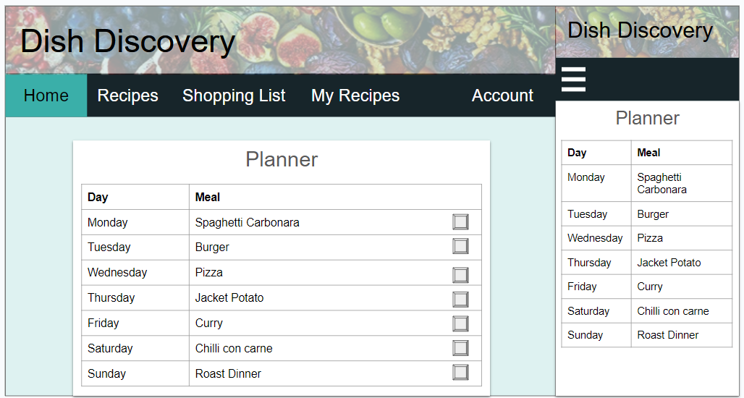

Figure 31. Home page view.

|  |  |
| --- | --- |
| Page ID | 3. Home Page |
| Info On Page | The home page has an individual planner for each user that they can add to, remove and edit. |
| Page Generation Details | This page generates a table for the logged in user from a database that contains a table for users and their planner. The recipes come from a recipe table that has all of the recipes in it. |
| Links To Other Pages | This page links to 5. My Recipes, 6. Recipes, 7. Shopping List and 8. Account. |
| Other Things Worth Noting | This page is individual to each user and is generated on loading the page once the user has logged in. |

### Admin Page

The admin page is exclusive to anyone with an admin account. This sort of account is very restricted and only has access to this page to change passwords. This page covers all of what the admin can do including logging out using the tab in the navigation bar.

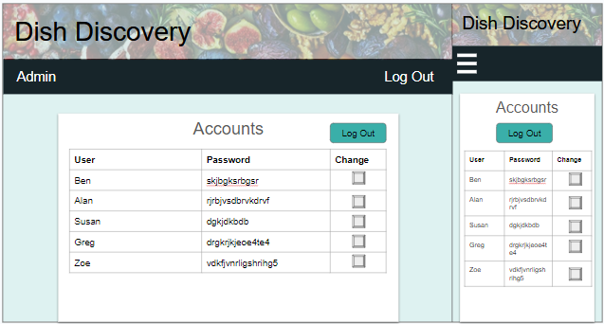

Figure 32. Admin page view.

|  |  |
| --- | --- |
| Page ID | 4. Admin Page |
| Info On Page | This page will contain all of the users' usernames and passwords as well as a way to change the password or remove the user entirely. |
| Page Generation Details | This page will get all of the users and their passwords from the users table and the password table and then print them all out into a table. |
| Links To Other Pages | This page is only accessible under the admin account. The admin only has access to this page to change user information. Admins can then log out to get back to the login page. |
| Other Things Worth Noting | None |

### My Recipes page

The “My Recipes” page does not display pictures of the recipes, just the name and the option to delete and edit them (Figure 33). The pictures are only there on other pages to make it easier for others to find the recipe they want. The option to edit and delete the recipes are exclusive to the person who made them which is the main reason for this page as it makes it easier to sort through the recipes. A simple query to get all of the recipes made by a specific user has it easy to display this data and edit or remove them if needed.

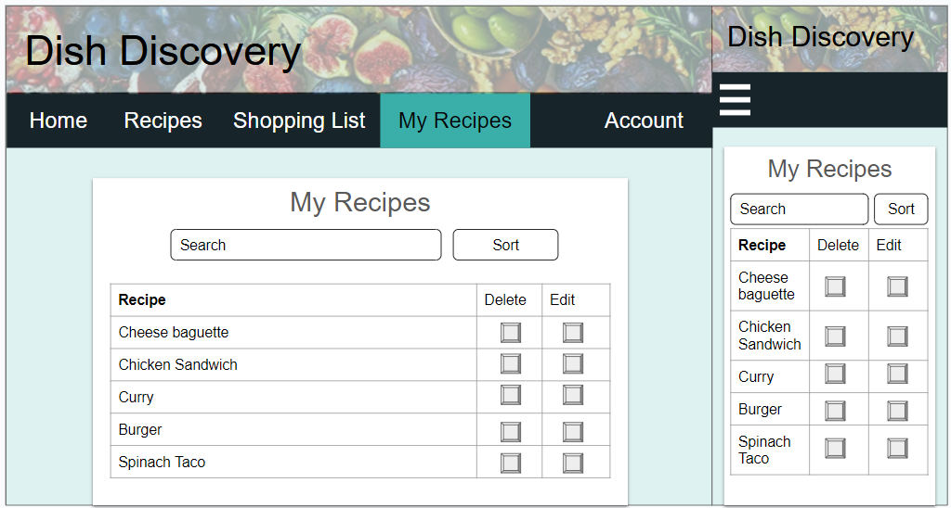

Figure 33. My Recipes page view.

|  |  |
| --- | --- |
| Page ID | 5. My Recipes |
| Info On Page | This page will display all of the recipes made by a specific user so they can edit or delete them. These are displayed in a table. |
| Page Generation Details | This page generates a table of all of the recipes that the logged in user created. A query will be used to search through the recipes table and return all of the recipes made by that user. |
| Links To Other Pages | This page links to 6. Recipes, 7. Shopping List, 8. Account as they are all on the navigation bar. It also links to 9. Edit recipe, 10. Selected Recipe and 11. New Recipe. |
| Other Things Worth Noting | The recipes are displayed in a table to save space and make them easy to find and change. The user who made the recipes do not need the images to know what the recipe is as they are the ones who made them. |

### Selected Recipe Page

The selected recipe page displays a full recipe and gives the user the option to add the meal to their planner (Figure 34 Figure 35). On this page users are able to add the recipe to their planner by selecting the day of the week in the dropdown menu in the popup (Figure 36).

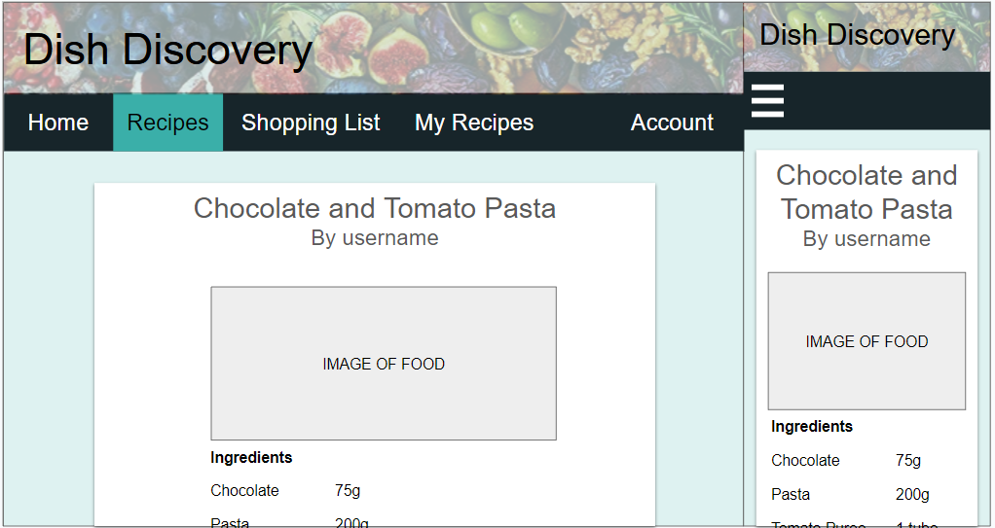

Figure 34. View Recipe page view.

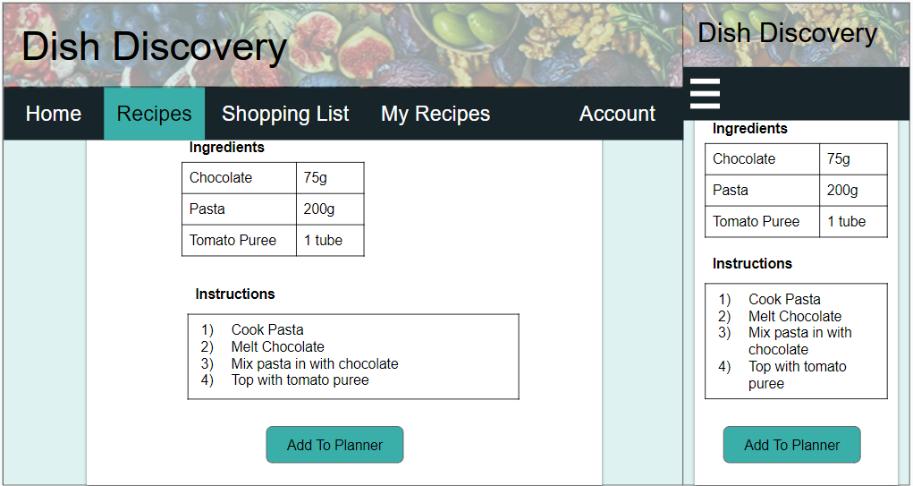

Figure 35. View Recipe page view.

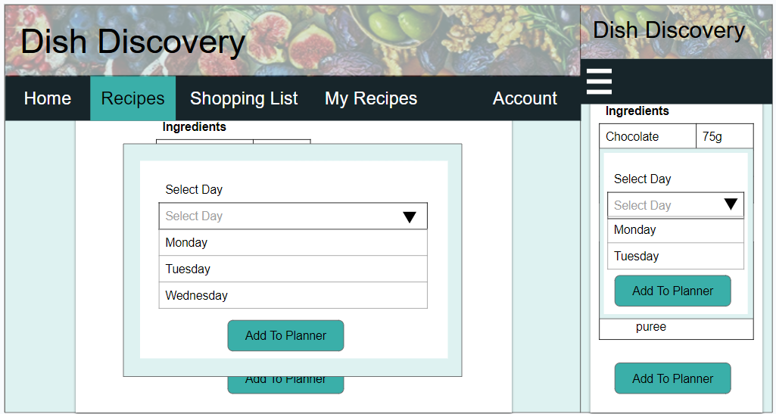

Figure 36. Select day for recipe view.

|  |  |
| --- | --- |
| Page ID | 9. Edit Recipe |
| Info On Page | This page contains options to change the recipe name, ingredients, instructions and the picture as well as a confirmation and cancel button. |
| Page Generation Details | This page contains a form that will already be filled out so users can edit an already existing recipe. This will update all of the already existing details of the recipe. |
| Links To Other Pages | This page links back to 5. My Recipes page when the recipe is changed or the change was cancelled. |
| Other Things Worth Noting | None |

### Shopping List Page

The shopping list page is a list that has extracted all of the ingredients from the recipes that have been saved in the weekly planner (Figure 37).

After some feedback a button was added to the prototype to add extra items to the shopping list but due to the time constraints, this feature was not added. This will be a feature that can be added in a future update as well as a button to remove an item off the list. To save these extra items would raise questions on how they would be stored for if the user closes the site. This data could be stored locally or in a separate column in a table that is linked to the user.

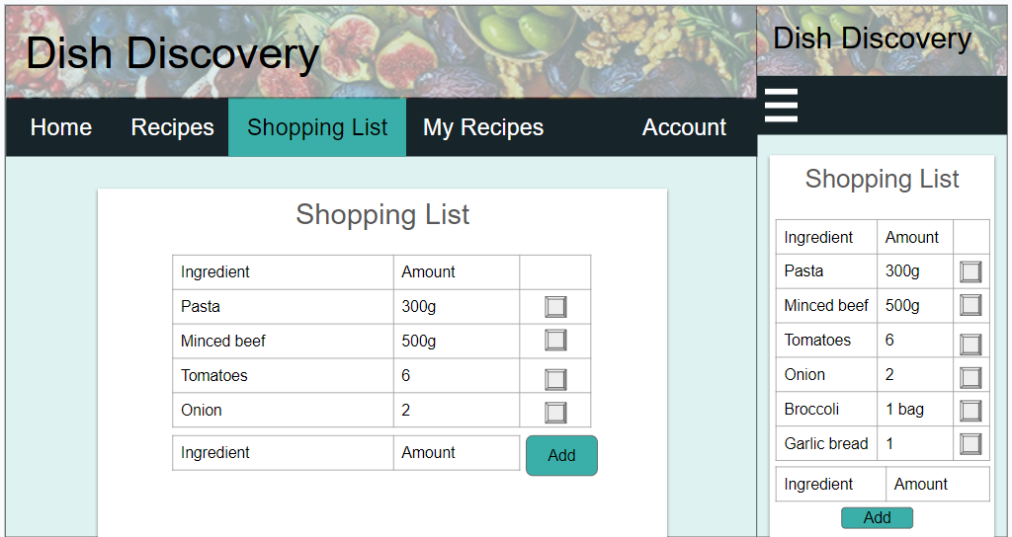

Figure 37. Shopping list page view.

|  |  |
| --- | --- |
| Page ID | 7. Shopping List. |
| Info On Page | This page contains all of ingredients from a user’s planner. These are all displayed in a table with a checkbox next to show if it has been selected to make it easier to check items off when the user goes shopping. |
| Page Generation Details | This page displays all of the ingredients from the recipes from the user's planner. They are all displayed in a table that is generated in JavaScript with a checkbox for users to toggle. |
| Links To Other Pages | This page links to 5. My Recipes, 6. Recipes, 8. Account as they are all on the navigation bar. This page does not link to any other pages. |
| Other Things Worth Noting | None |

### Account Page

The account page allows users to log out and change their password (Figure 38). The Key is displayed here so users can share it to their friends.

This page covers some of the use cases including being able to log out and change the password. This gives users more options to change their information if they get anything wrong in the initial account creation process.

In the final product, users are not able to change their username or delete their account as this caused some issues with some of the other tables. Deleting an account would require some recipes to be deleted or for the creator to be changed. A solution to this could be to archive the user data so these recipes can still exist.

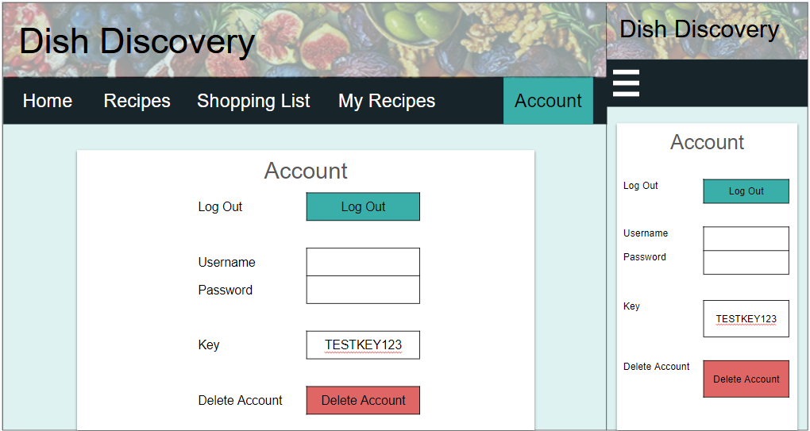

Figure 38. Account page view.

|  |  |
| --- | --- |
| Page ID | 8. Account |
| Info On Page | This page displays the username, password an option to remove account, option to log out and the key so the user can share it to others who wish to use the site. |
| Page Generation Details | This page is generated mostly in html with some of the boxes being filled in with JavaScript. The username and password is fetched from the database to be displayed in the username and password box to allow users to change them. |
| Links To Other Pages | This page links to 5. My Recipes, 6. Recipes, 7. Shopping List as they are all on the navigation bar. This page does not link to any other pages. |
| Other Things Worth Noting | The content will be generated depending on the user so another user's user is not displayed where it is not supposed to. |

### Edit Recipe page

The edit recipe page has all of the key sections to edit a recipe (Figure 39 Figure 40). To add ingredients the user will type in an ingredient, an amount along with its unit and then press the “add ingredient” button to add an ingredient to the list. Once the form has been filled out the user can then confirm the recipe or cancel it.

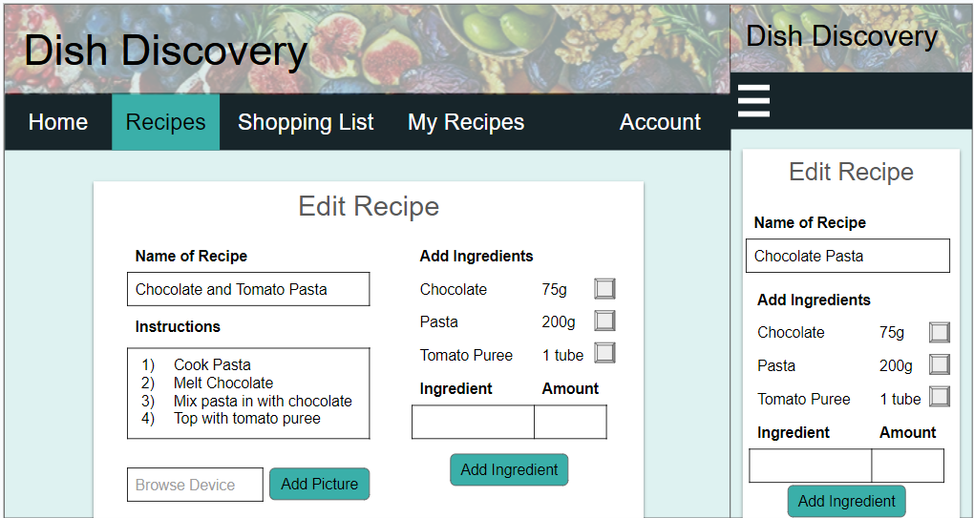

Figure 39. Edit recipe page view.

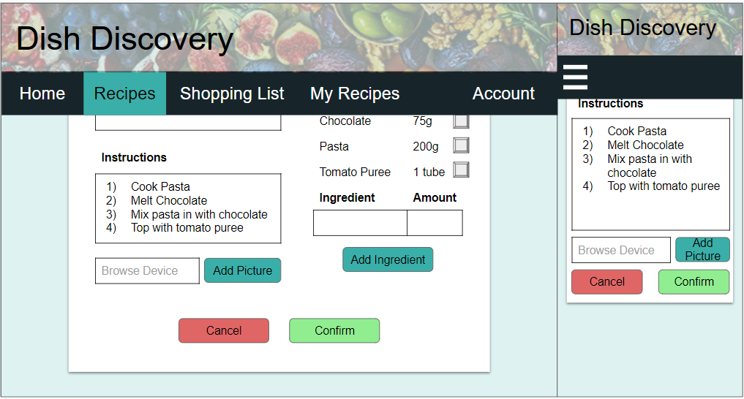

Figure 40. Edit recipe page view.

|  |  |
| --- | --- |
| Page ID | 9. Edit Recipe |
| Info On Page | This page contains options to change the recipe name, ingredients, instructions and the picture as well as a confirmation and cancel button. |
| Page Generation Details | This page contains a form that will already be filled out so users can edit an already existing recipe. This will update all of the already existing details of the recipe. |
| Links To Other Pages | This page links back to 5. My Recipes page when the recipe is changed or the change was cancelled. |
| Other Things Worth Noting | None |

### Recipes Page

The recipes page contains all of the recipes that users can view (Figure 41). Each of the recipes are viewed by clicking on the cards. In the prototype recipes can be sorted and searched for using the search bar and the sort button. The layout is the same for mobile but the cards are displayed differently depending on screen size.

In previous versions there was not an add recipe button to make a new recipe. This button was added due to the feedback given in the questions in the evaluation. The desk top version of this site contains a button that has the text “Add recipe” whereas the mobile version will contain a button that has a “+” symbol in it to save space. Using the “+” symbol is well known to mean add something and in this case to add a recipe. The add recipe button was later changed to both be a button with “+” as the header was covered by the button on the mobile version. The sort feature was also removed as the search bar was more flexible.

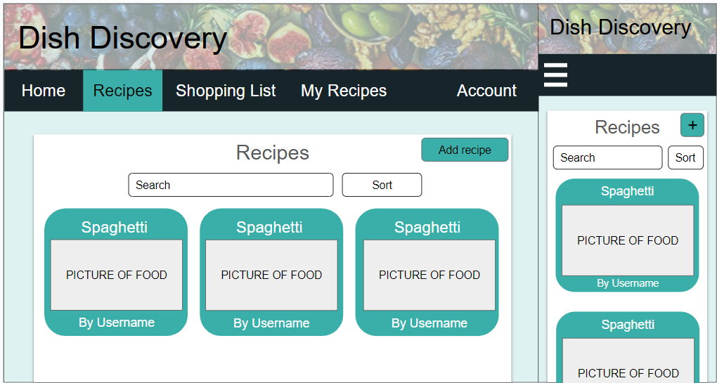

Figure 41. Recipes page view.

|  |  |
| --- | --- |
| Page ID | 6. Recipes |
| Info On Page | This page displays all recipes by all users and has options to search and sort the results. From here users will be able to create recipes also. |
| Page Generation Details | The page uses html to generate the template of the page and then each of the recipes are displayed in their own cards once the data is collected from the database. Each card will be clickable to take the user straight to that recipe. |
| Links To Other Pages | This page links to 5. My Recipes, 7. Shopping List, 8. Account as they are all on the navigation bar. From this page users will be able to go to 10. Selected Recipe and 11.New Recipe. |
| Other Things Worth Noting | On the navigation diagram there is a line to edit recipe. This is due to overlapping lines but this page only has access to 10. Selected recipe to view it and 11. New Recipe to make a new one. |

### New Recipe Page

Add recipe page has all of the key sections to make the recipe (Figure 42 Figure 43). To add ingredients the user can type in an ingredient, an amount along with its unit and then press the “add ingredient” button to add an ingredient to the list. Once the form has been filled out the user can then confirm and make the recipe or cancel it. The recipe will then be made and displayed on the recipes page.

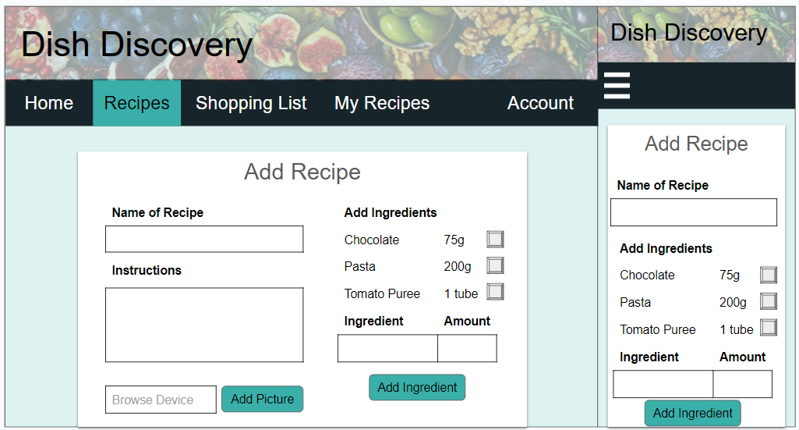

Figure 42. Add recipe page view.

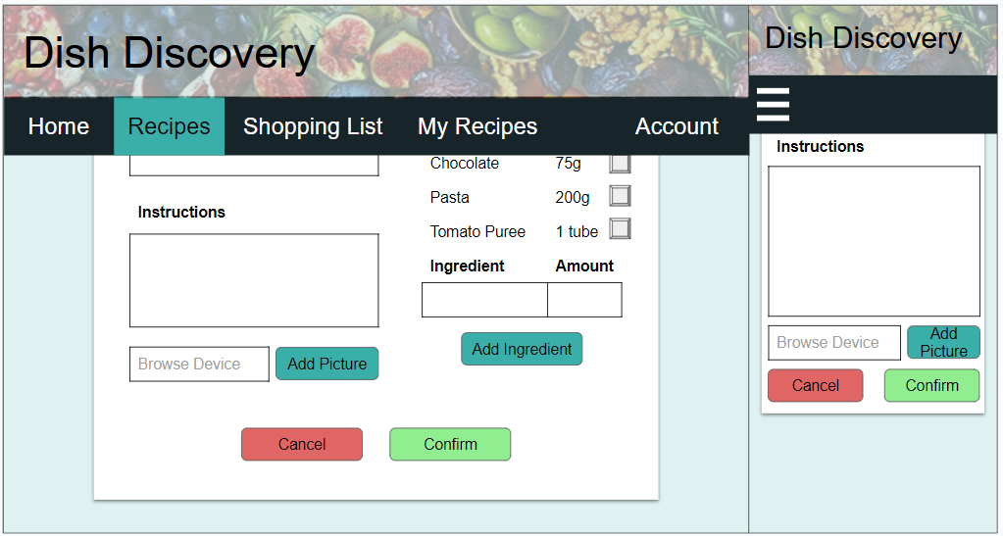

Figure 43. Add recipe page view.

|  |  |
| --- | --- |
| Page ID | 11. New Recipe |
| Info On Page | This page is similar to 9. Edit Recipe but all of the text boxes are blank. There is a form for users to fill in that includes the recipe name, recipe image upload, ingredients and instructions and then a button to confirm or cancel the creation of the recipe. |
| Page Generation Details | This page contains a form that is empty that will be used to fill in the data to add a new recipe. |
| Links To Other Pages | This page only links back to 5. My Recipes and 6. Recipes. |
| Other Things Worth Noting | None |

### Help Page

The help page contains a range of questions and answers that should help any user when using the site. It covers how to use certain features of the site including creating and editing recipes, viewing planner and adding/removing from a planner.

|  |  |
| --- | --- |
| Page ID | 12. Help |
| Info On Page | This page contains some questions and answers to help the user carry out tasks on the site. |
| Page Generation Details | The page will show the questions and answers on generation. |
| Links To Other Pages | This page will link to the other pages that are displayed on the navigation bar. |
| Other Things Worth Noting | None |

## Evaluation

The evaluation consists of 5 potential users evaluating the design to see how easy the site is to navigate and to see what could be improved. 5 users is the minimum amount of users to test in a qualitative set of questions as 85% of the issues according to Jakob Nielsen and Tom Landauer (Budiu, 2021).

The set of following questions are a mix of quantitative and qualitative questions to find out some of the positive and negative parts of the design as well as the use cases mentioned in the business analysis and then find a solution to improve them. This feedback will be taken into account and implemented in the final product to make a usable site to create and share recipes. These questions aided in making sure that the prototype was the best it could be with all of the necessary functions that a user would need. It also aided in improving the site visually and in its usability with suggestions such as adding more images and having some sort of help for using the site.

The full questionnaire can be found at: <https://docs.google.com/forms/d/e/1FAIpQLSfExFR8jq_juZhIbg5rC9W_r42GhtlOBCgyh-lKuw0wguTEZw/viewform?usp=sf_link>

All of the responses can be found in the Appendix.

1. **On the landing page, how easy was it to find out where you had to log in/register?**

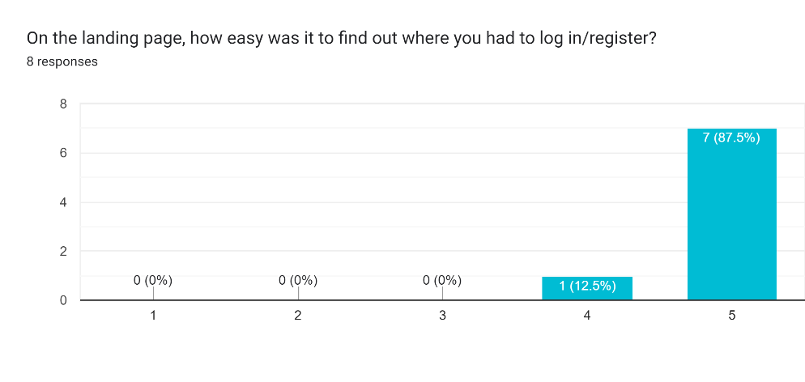

Figure 44. Graph to show how easy users found it to find the login/register option.

1. **Is there anything that could be improved on the landing page to make it more clear?**

The feedback given to this question is that pictures and symbols would be useful to make the site more visually pleasing and to help the users with visual metaphors such as a piece of paper next to recipes.

Another suggestion from the feedback was to make sure the formatting of the words in the navigation bar are not going to a new line, instead make sure they are all on the same line. This would be easily changed and when implementing the design properly, this will not be an issue. Another suggestion for the navigation bar was to remove page name that they are already on to avoid confusion. To counter this, the current page tab is a different colour to show the user where they are on the site.

1. **How simple is it to log in/register to access the site?**

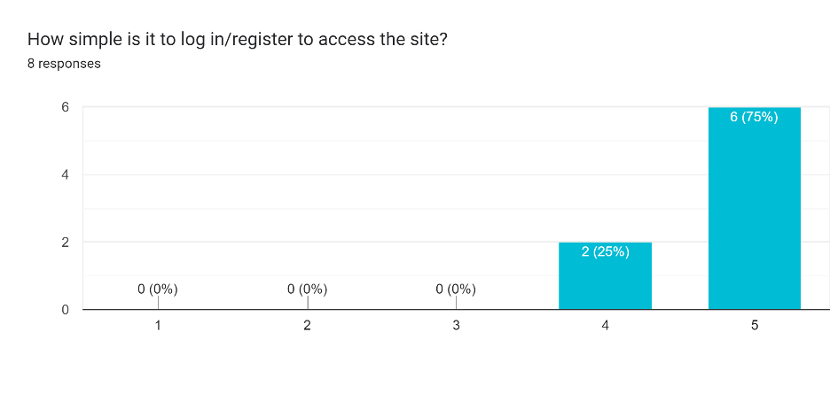

Figure 45. Graph to show how easy users found it to access the site by logging in/registering.

1. **Are there any improvements that you would like to see regarding the login page?**

The feedback for the login page is making sure the users know what the key is and where to find it as well as separating the login and registration page to make them more distinguishable. Another small bit of feedback is making the colours of the buttons the same colour to make the site look more uniform.

While it would be good to split the page into login and registration, having them on the same page means that there will be no need for extra pages. As well as this, the headers above each section clearly label the information the user needs to fill in. Another option, instead of splitting the page, would be to have a switch that adds and removes Divs depending on which whether the switch is on or off.

1. **List the pages you would go through to get to a recipe?**

While there was some variation when users were asked to navigate to view a recipe, the majority of the answers followed the same path of logging in to get to the home page and then selecting the recipes tab. From there they would click on the desired recipe. This short journey from login to the recipes page was intentional as recipes is one of the main tabs in the navigation bar and should be accessed quickly if needed.

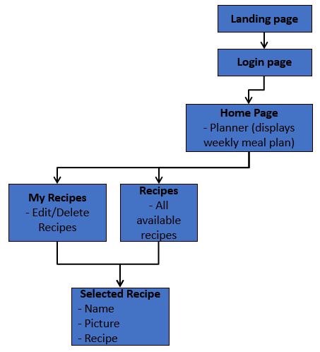

Figure 46. Navigation diagram to get to a selected recipe.

1. **How easy is it to find the recipe that you want to view?**

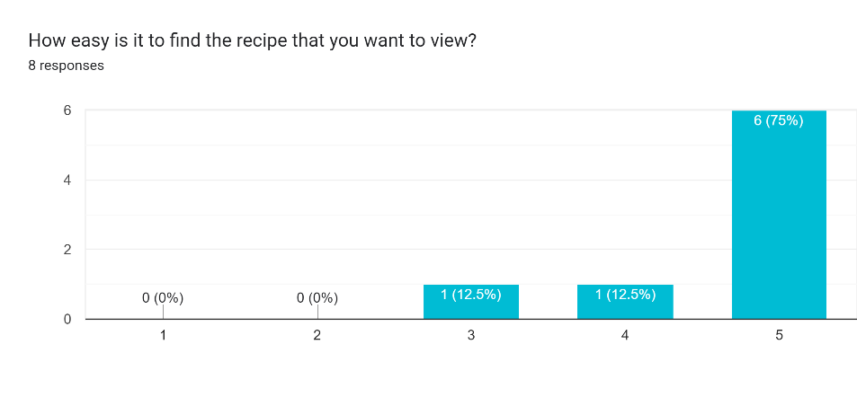

Figure 47. chart for how easy it is to find a recipe.

1. **How clear and/or easy to follow are the recipes? (question on formatting of the page)**

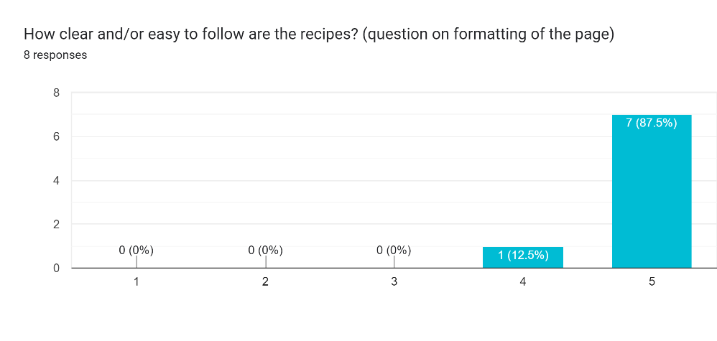

Figure 48. Chart for how easy it is to follow the recipe.

1. **What could be improved with the recipe system?**

One suggestion to improve the recipe system would be to add help buttons next to options to give the user more information on what they could do. Another was to add a dropdown box next to the add to planner to avoid having the popup and reducing the number of clicks. This is a good idea as it will remove the need for a popup and an extra button to confirm or cancel.

1. **What pages would you go through to see your shopping list?**

Like with question 5, the users all gave the same answer, and all took the intended route to get to the shopping list. This option is also one of the main navigation bar tabs to allow for quick access.

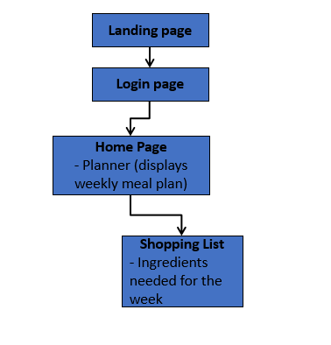

Figure 49. Navigation diagram to get to the shopping list.

1. **How easy is it to view the shopping list?**

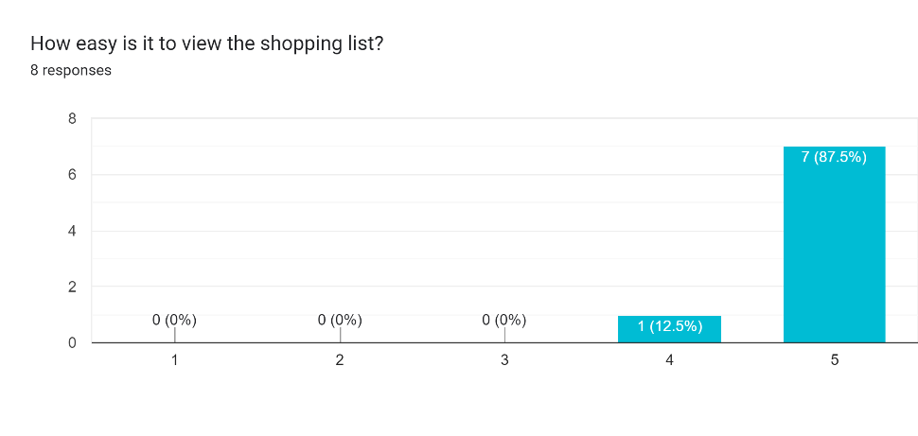

Figure 50. Chart to show the difficulty of viewing the shopping list.

1. **How easy is the shopping list to follow?**

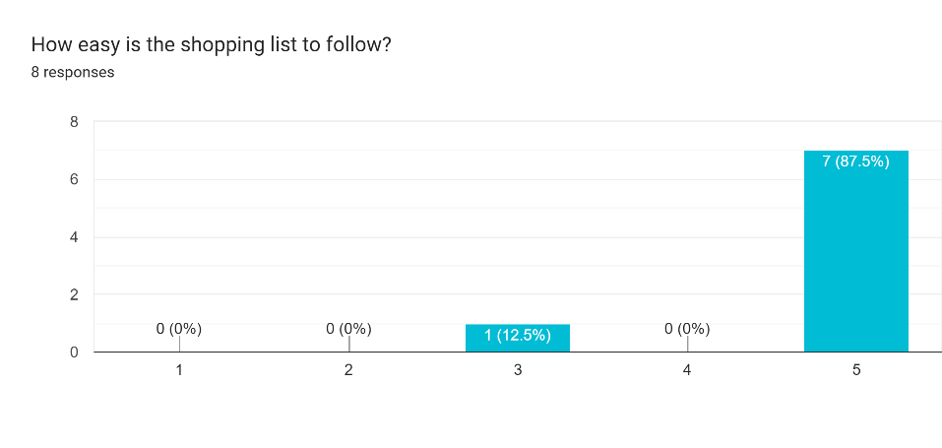

Figure 51. Chart to show difficulty of following the shopping list.

1. **What would you improve about the shopping list feature?**

For the shopping list, users recommended that having an option to add more items to the list that are not on the planner would be helpful. Another is to add more symbols to show categories which items come under e.g. meat, veg and fruit.

Another suggestion was to allow users to add and remove items from the shopping list that may or may not be needed due to already owning that ingredient or needing to add other important items to the list that are not part of the recipes.

1. **How easy is it to create a recipe?**

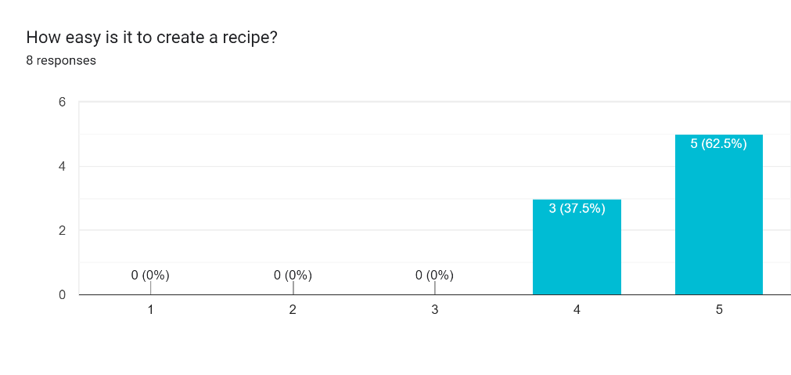

Figure 52. Chart to show the difficulty of creating a recipe.

1. **What could be improved about creating a recipe?**

The user suggested improvements for creating a recipe would be to include different measurement options and a unit converter to make it easier to measure ingredients.

1. **What improvements not already mentioned that you would like to see that could be implemented into the final product?**

Finally, an extra feature that was suggested is to have a page for people to see recently added recipes that they can share that is similar to a Twitter/X feed. This feature was something that was thought about in the early stages but was left as it may be hard to implement in the short time to create the site.

## Persistent Data Model

The site only needed three tables to be able to provide for all of the use cases. The users table stores the user information for users to log in. The planners table contains all of the planners for each of the users and stores the IDs for the recipes that the users have selected. Instead of using the recipe names, IDs have been used so that there can be multiple recipes with the same name. The Recipes table contains all of the recipes and the information related to them. The Recipes table links to the Users table as users can have multiple recipes and their name is referenced in the creator field. The username is used as the reference instead of the userID because each username is unique.

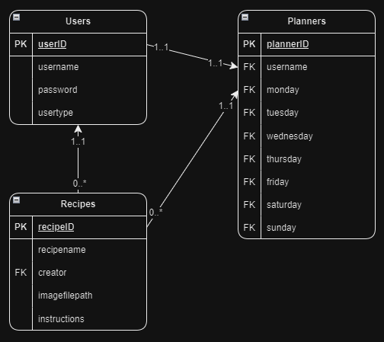

Figure 53. Diagram of the tables in the database and how they link.

## Tables and Data

### Users Table

The users table consists of a userID as the primary key, the username, the hashed password and the user type which defaults to regular as there will only be one administrator for now.

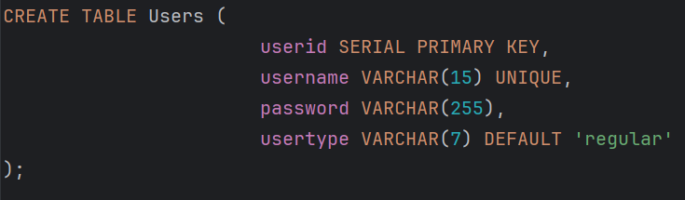

Figure 54. Query to create the users table.

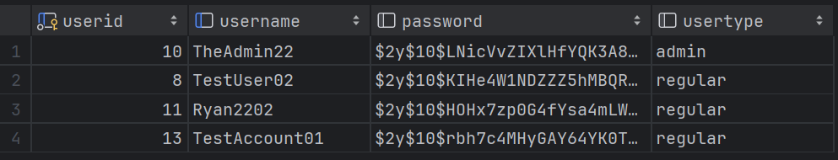

Figure 55. Users table with two example users.

### Recipes Table

The recipes table contains all of the recipes that users have created. There are some character limits on some of the fields to avoid too many characters in the forms. This table needs the username from the users table to fill the creator field and this is done with the foreign key.

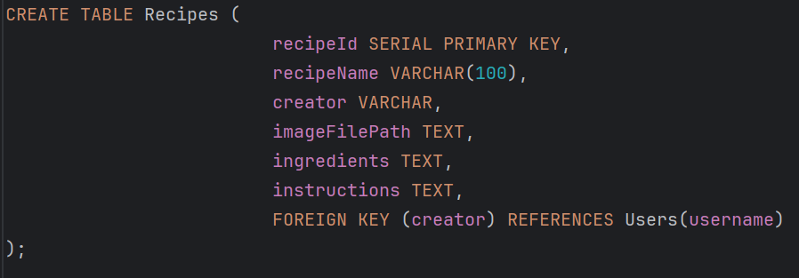

Figure 56. Query to create recipes table.

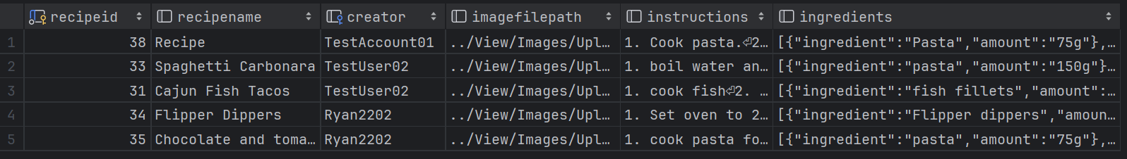

Figure 57. Recipe table with an example recipe.

### Planners Table

The planner table stores the planners of each user and uses foreign keys to populate the table on the planner page for each user.

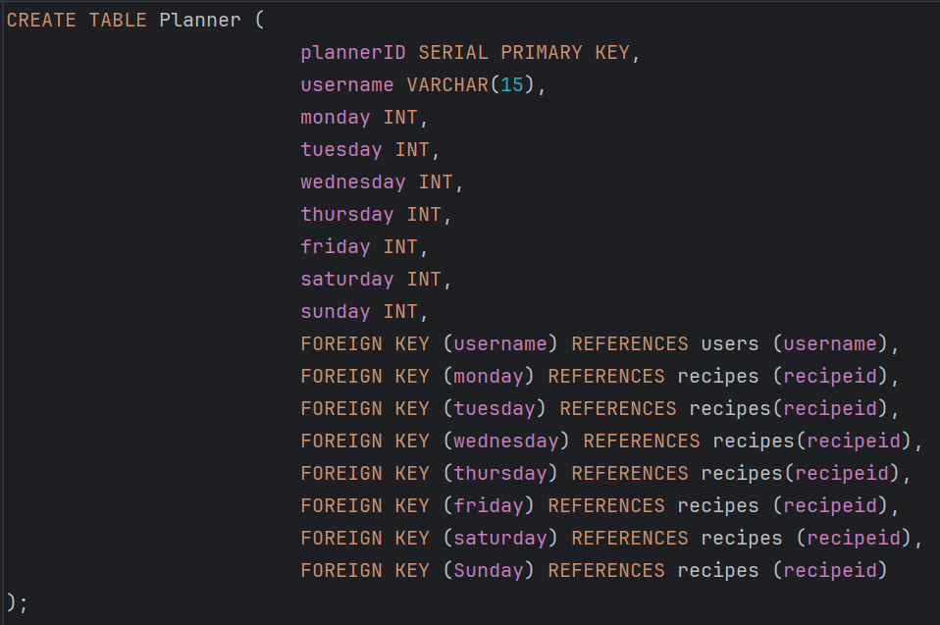

Figure 58. Query to create the planner table.



Figure 59. Full table of the recipe IDs in the planner.

### Front End Test Data

Figure 60 shows some of the original test data to see how the recipes could be displayed before attempting to fetch or store them in the database. The aim was to handle the recipes in a JSON format to easily access the information. The ingredients were also turned to JSON to be able to loop through them to display them. The instructions section of each recipe had all of the steps of the recipe. Originally, like in Figure 60, Each line was separated with “<br>” to start a new line at each step but this had unnecessary extra steps when adding then editing the recipe. This was later changed to add the “<br>” tag before displaying the recipe as the new lines were saved when the recipes were created.

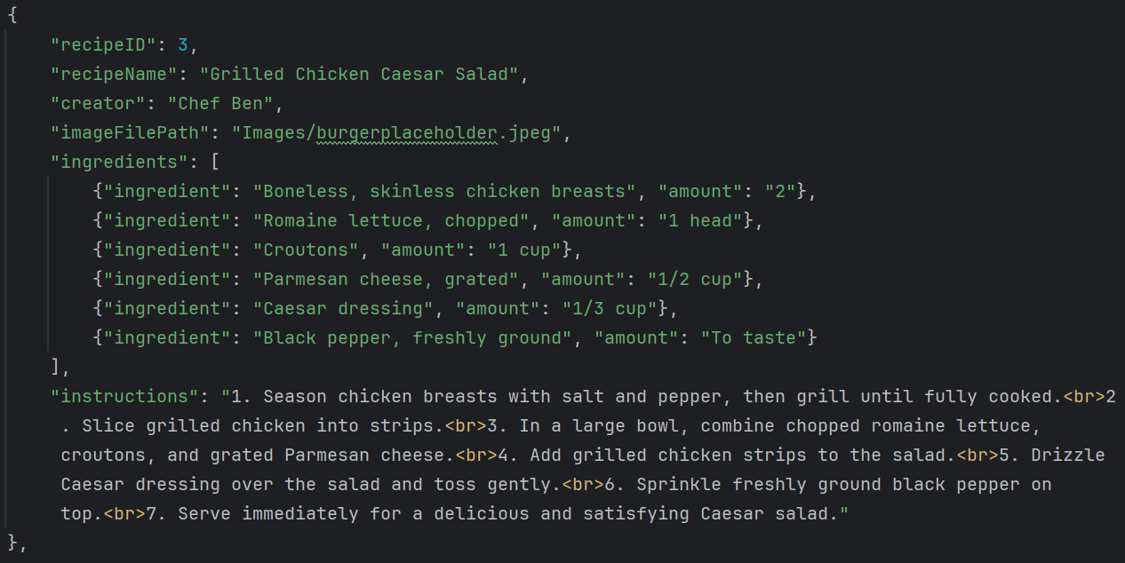

Figure 60. JSON of an example recipe.

# Implementation

## Development Schedule

When in the development phase, a development tracker was used to track features that have been implemented at a certain point and what would be in each release.

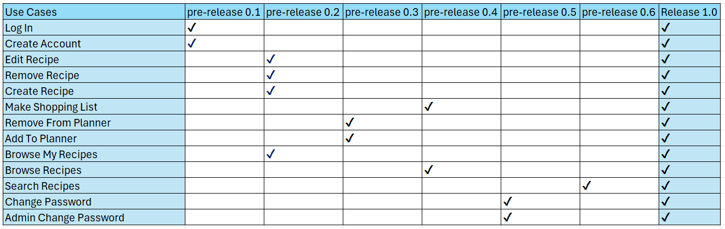

Figure 61. Release table.

## Frameworks And Tools

The first step I took in the implementation stage was to create the folders needed to store the different files that would be needed. These would be Model, View and Controller (MVC framework) (Geeks For Geeks, 2024). The model is used for all of the database interactions, the view is for handling the presentation of the data, and the controller is used for handling request flows and logic. In this case it also handled some of what the user sees by populating tables and creating recipe cards.

The languages that were used to create this site from scratch were HTML and CSS for the look of the site, JavaScript for the front-end functionality and some of the looks of the site, and PHP for managing the data. To help with any PHP functions that I was unsure about, I used php.net to get a good understanding of the functions I used (PHP Group, 2024).

A front-end framework that was used was Bootstrap as I was already familiar with it, and it provided a good way to add responsiveness to the site for when users with smaller devices wanted to use it. Bootstrap also has an MIT license which allows for free use of it (Bootstrap, 2024). It also provided other tools such as buttons that have hover and clicked looks to them by adding the Bootstrap classes. I also used the Bootstrap navigation bar because it has a built-in responsive burger menu that makes the site look nicer and easier to use on a mobile device.

jQuery was also used in some cases to display cards for the recipes page as it was a more efficient to use it instead of using pure JavaScript.

## Issues Faced

A difficulty I had was figuring out how to save user uploaded images. After some research I learned that I needed to use move_uploaded_file. This would put the image file into the correct directory under a new name.

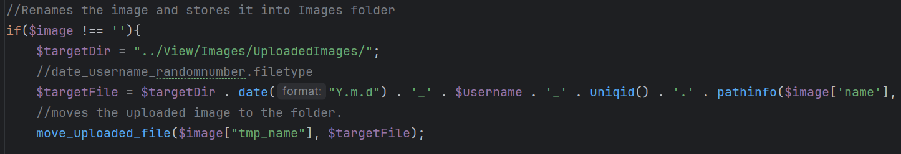

Figure 62. Code for saving an image.

Before the image is sent through the code in Figure 62 the image needed to be validated so I had to research how to check the file type before saving it to avoid anything other than an image being saved (Figure 63).

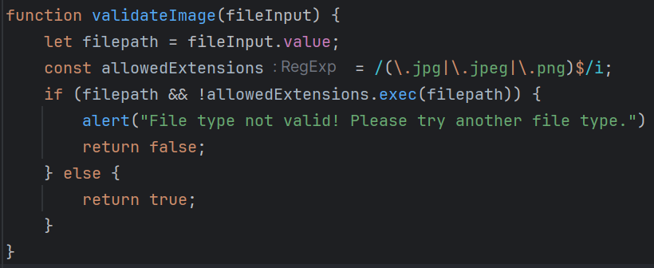

Figure 63. Image file validation.

Another issue that I faced was when I was trying to delete a recipe that was already saved in a planner. The recipe could not be deleted due to the fact that the recipe ID was being used in a planner, so the recipe had to be removed from the planner before removing it from the recipes table. To solve this, I added a new query to clear any use of this recipe in any planner using the “CASE” expression to get every case of the recipe ID then change it to null like what would be in a planner if the day was empty (W3 Schools, 2024).

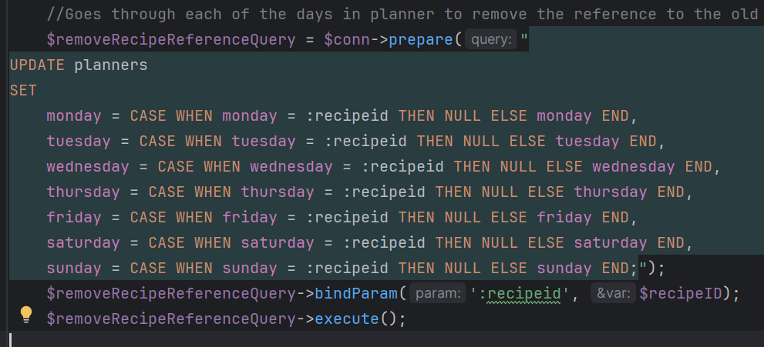

Figure 64. Code to clear any uses of the recipe that is being deleted.

Another major issue that I faced was when I was trying to get a planner for a specific user. Originally, the userID was used to link the planner to the users table but it was found to be easier to use the username instead because the usernames were still unique, and it made it easier to get the data by just using the session variables already created.

When attempting to navigate to different pages in PHP I first tried to use the header function to change pages, but I ran into an issue where the pages would not change. To solve this, I decided to find a way to send the file path of the new page to the JavaScript and then use the JavaScript equivalent to redirect the user. The solution I found to the redirection issue was to echo an array that was turned into JSON that also had an element in the array called success, which was used to tell the front end that the JOSN that was returned if the answer from the back end was successful or not. Figure 65 shows that the response is fetched and then turned into JSON to be able to access the information inside of the response.

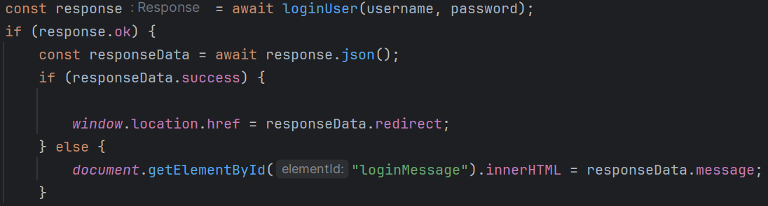

Figure 65. Example of how if the response is successful, it will redirect the site, else it will display the message.

The data that gets sent to the small part of the code in Figure 65 is set up in the PHP script. This can be seen in Figure 66 in what is being echoed. It echoes an array with the positions in the array being called success which is a Boolean and either redirect or message to either redirect the user or send a message stating why this action cannot be carried out. I found a similar use of using an array to return data on a post on stack overflow that was also to do with redirection, but they still used the header. I used one of the other lines they had to return an error message to be able to return the file path as the headers would not work in this project (Stack Overflow, 2024).

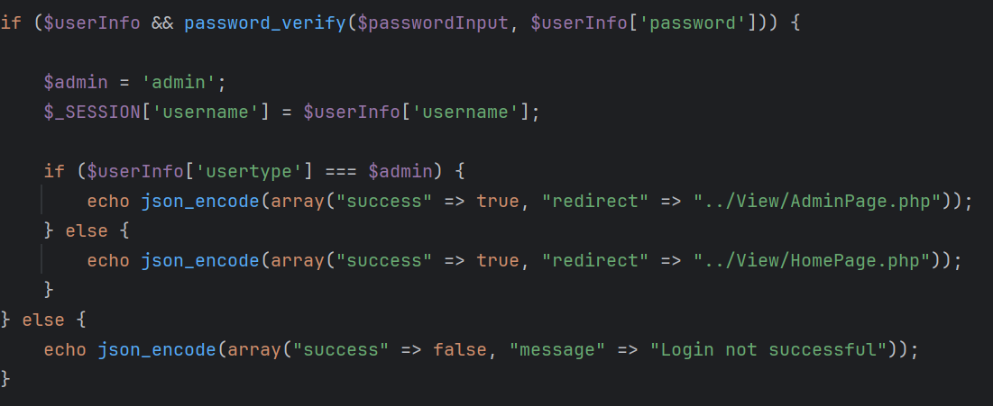

Figure 66. Small statement that shows how the site is redirected or how a message is passed to the JS file.

The final issue was getting the site to display properly on a mobile device. This was down to an issue with the information in the meta tags. It was not taking into account the device screen width so was displaying the site as if the smaller screens were the same as a desktop screen. To change this, I added “<meta name="viewport" content="width=device-width">” (Noble Desktop, 2024).

## Persistent Data Management

To store the persistent data, I used a PostgreSQL (PostgreSQL, 2024). I used PostgreSQL as it was a RDBMS that I was familiar with because I have used it in other projects and it was open source with a license similar to the BSD or MIT licenses (PostgreSQL, 2024). This means that it can be used freely. Before sending the data to the client side, the data is turned into JSON to easily transfer the data and access it.

# Achievements

## Improved Skills

While working on this project there has been some personal achievements that stood out. The first was improving my skills when programming in PHP. Before starting this project, I was not too confident in my PHP skills but after working on this project, I feel I can confidently use PHP in future projects. This included using sessions to save data that is used temporarily and being able to save/remove images in a folder in PHP. This was a big learning curve as I had to learn how to do these to add the relevant use cases and complete the site.

## What Went Well

While working on this project there were many things that went well. One of the things that went well was the completion of the project without having any major issues with the use cases that were implemented. Another was successfully creating a site that can be used on a day -o-day basis that the client is happy to use with no issues. Finally, something that went well early on was having a strong business analysis, UI design and evaluation and technical design before starting development and the report as it meant that I was very prepared and had a good idea of what was needed in the site down to the functions and handling of data.

## Site Breakdown

The site can be found at: <https://users.aber.ac.uk/ryj7/WebBasedMajorProject/Dev/View/index.php>

To create an account the key is TESTKEY123.

### **Landing Page**

The landing page content or look has not changed from the most recent design. The only thing that has changed was the image in the header as this one is open source and matched the colour scheme a lot better than the previous picture. The header picture was used from Pexels.com which is a free stock image site that allows anyone to use their content for anything (Pexels, 2024).

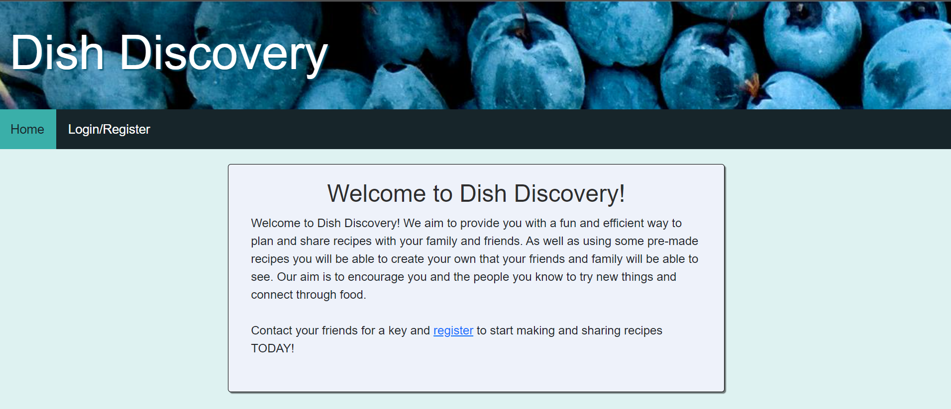

Figure 67. Landing page.

### Login Page

The login page has not changed when it comes to the aesthetics and layout of the page. The page has the data validated on the front end in the JavaScript using regular expressions to make sure no forbidden characters are sent. Once the user data is sent to the back end, it is validated again to do further checks, again, using regular expressions.

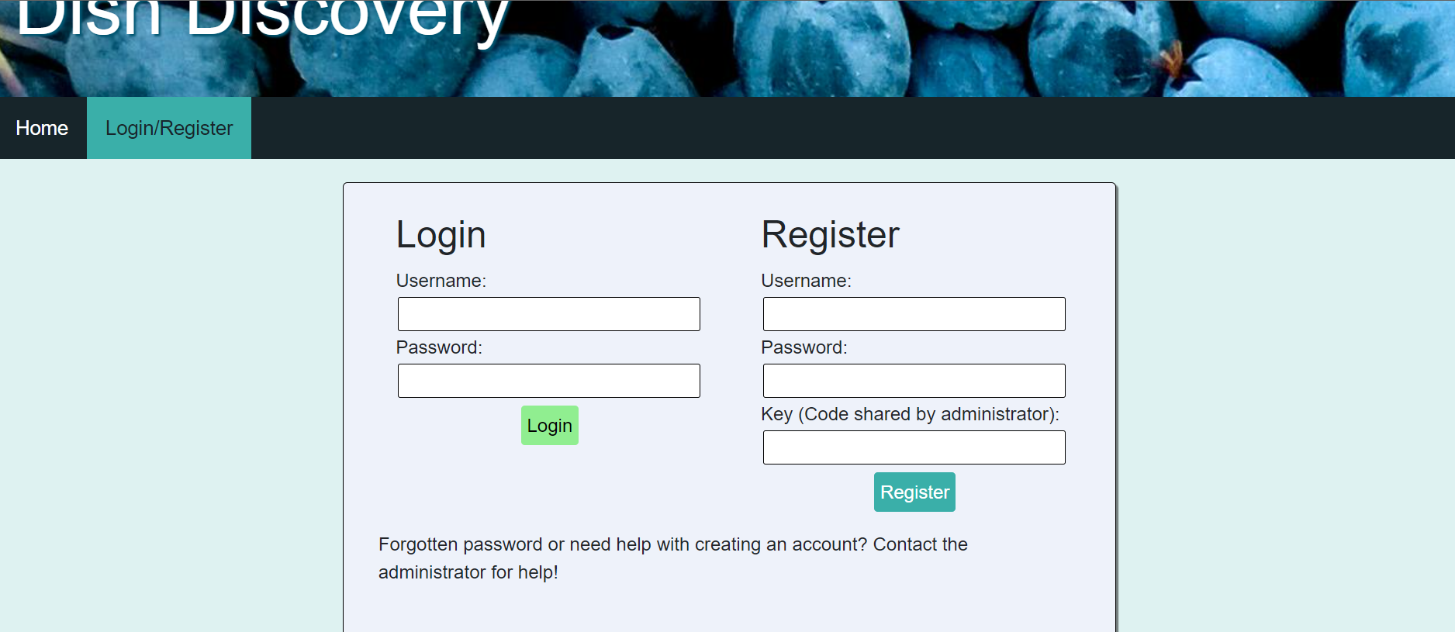

Figure 68. Login/register page.

### Planner Page

The planner page has changed slightly from the original design by adding an extra row for the remove from planner button. The buttons are also labelled better with a column for them and a bin icon on to represent the removal of them.

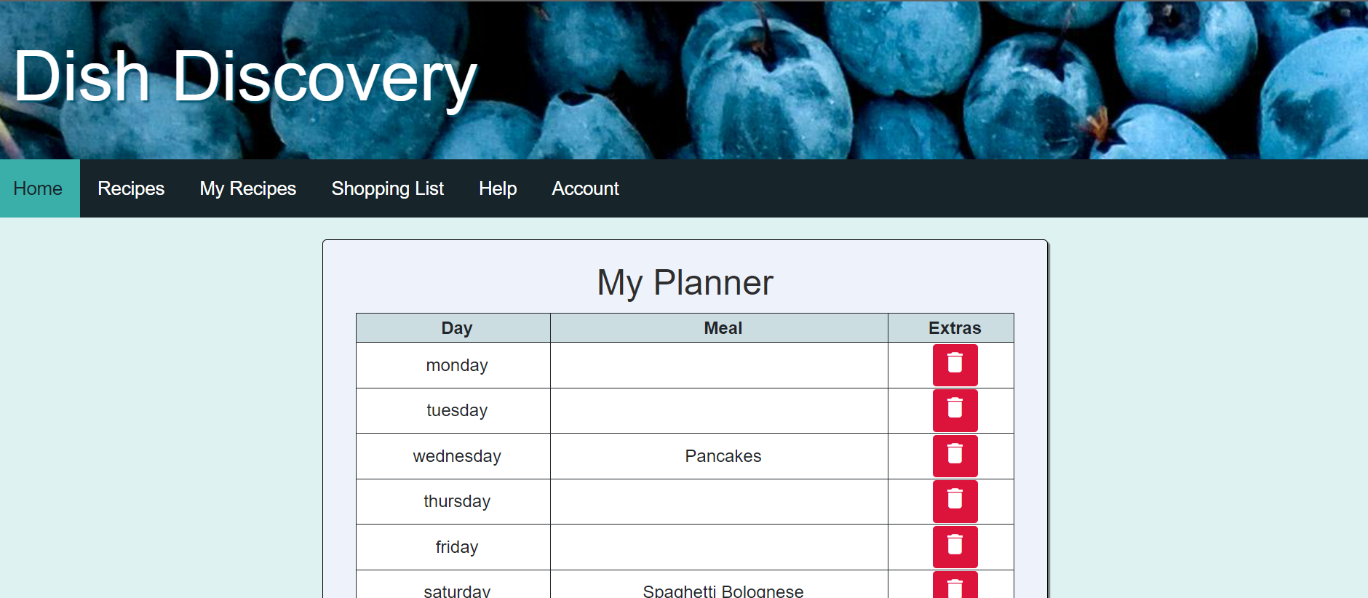

Figure 69. Planner page.

### Recipes Page

The recipes page has changed when it comes to the design as the cards are now different with them being different colours and widths to fit on the page better. The recipes are fetched from the database, stored in an array then displayed one by one. When a recipe or user is searched for in the search bar, the recipes that meet that criteria are displayed out of the array instead of fetching the recipes each time. The addition of a refresh button displays all of the recipes again if the user wants to see all the recipes again. A feature that was removed was the “sort” button which wasn’t necessary with having a search bar implemented.

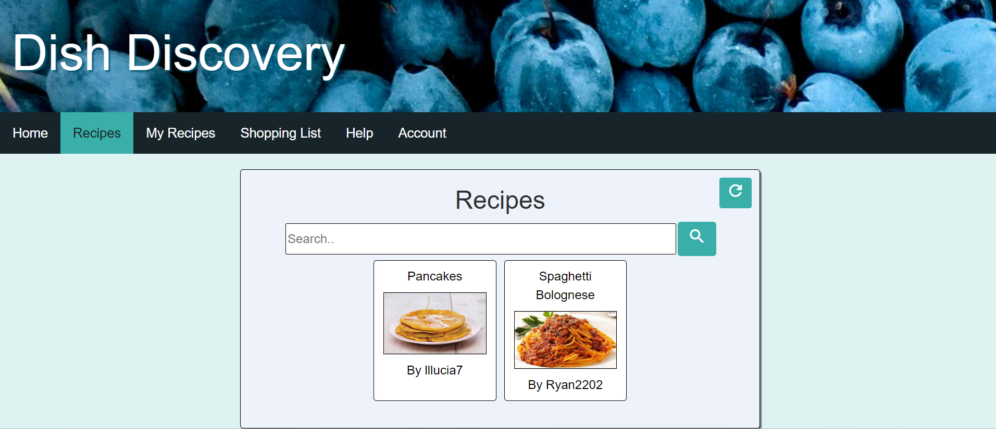

Figure 70. Recipes page.

### My Recipes Page

The “my recipes” page is similar to the recipes page with how the recipes are fetched and displayed. The only difference is how they are displayed. Instead of being in cards, the recipes are displayed in tables. The same principle of looping through the recipes to display them is being used. The buttons in the table allows the user to remove or edit the recipe and these have stayed the same since the original prototype that can be seen in Appendix C.

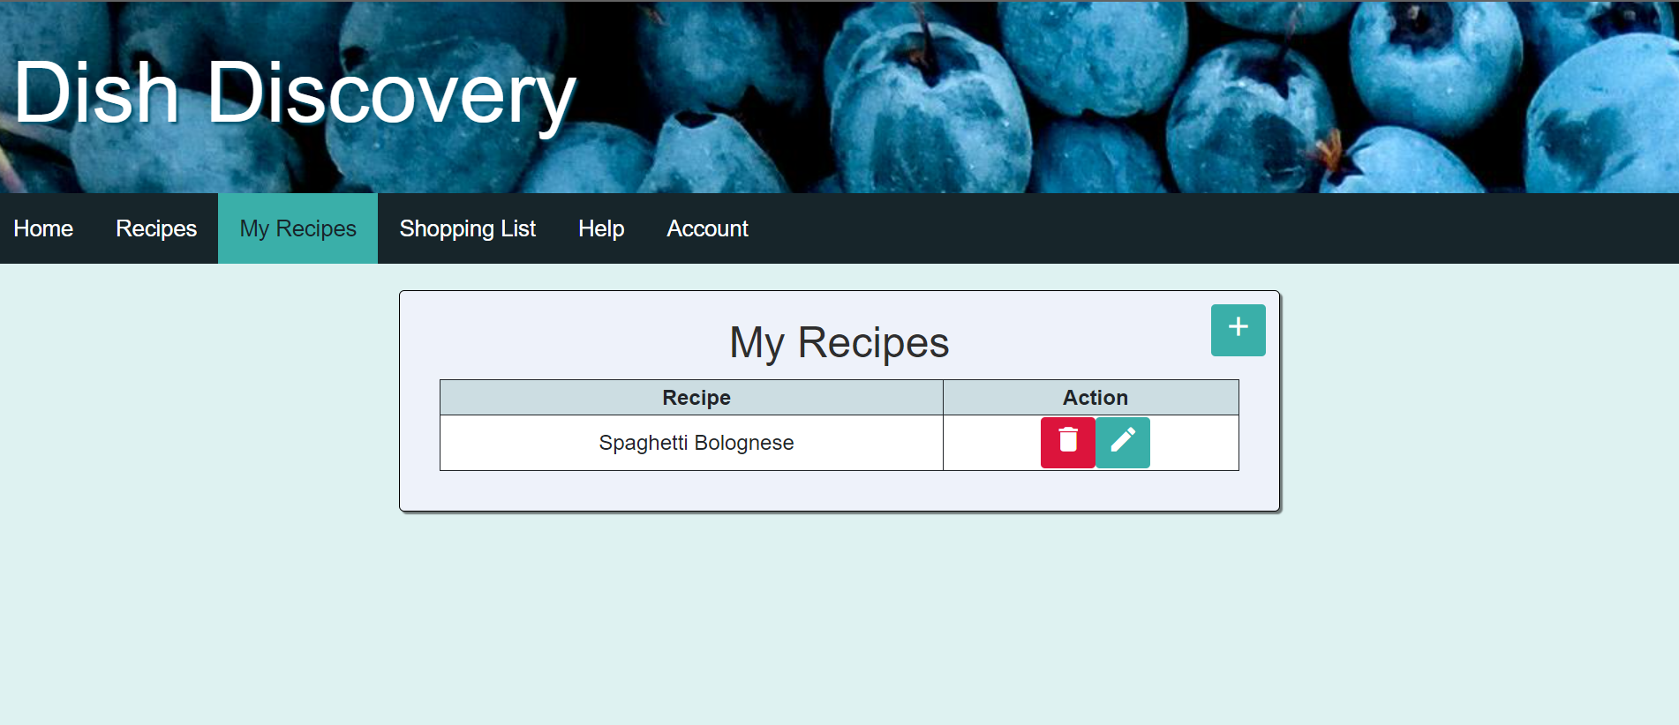

Figure 71. My recipes page.

### Shopping List Page

Compared to the most recent prototype, the shopping list page has changed with some features being removed. The main feature removed was having the ability to add more ingredients to the list. The issue with having this feature was that the shopping list had to be changed every time the planner was changed. With the shopping list changing so much, I was unable to find a way to save items to the shopping list while also having the ability to change it every time the planner was changed. The new features that were added was to be able to cross out an item or delete it temporarily. To get the list back the page just has to be refreshed.

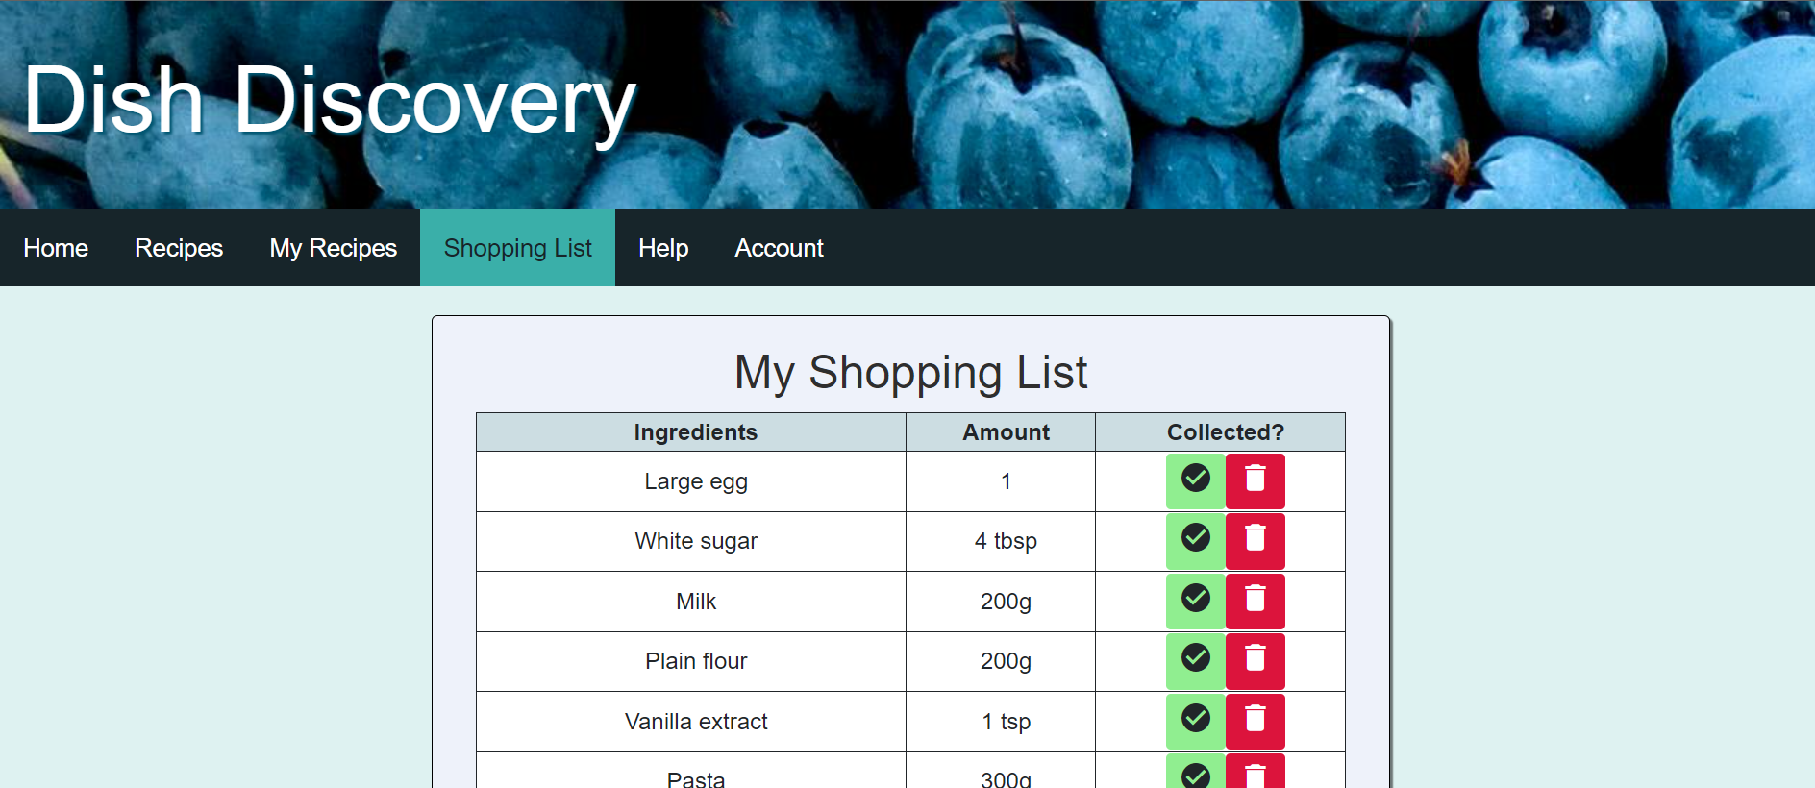

Figure 72. Shopping list page.

### Help Page

The help page is a new addition to have all of the information on how to use the site. It was easier to have all of the information in one place instead of having small help buttons everywhere. This reduced the number of extra divs and files needed to create the site. There is no data passed to this page. The questions and answers are added in the html.

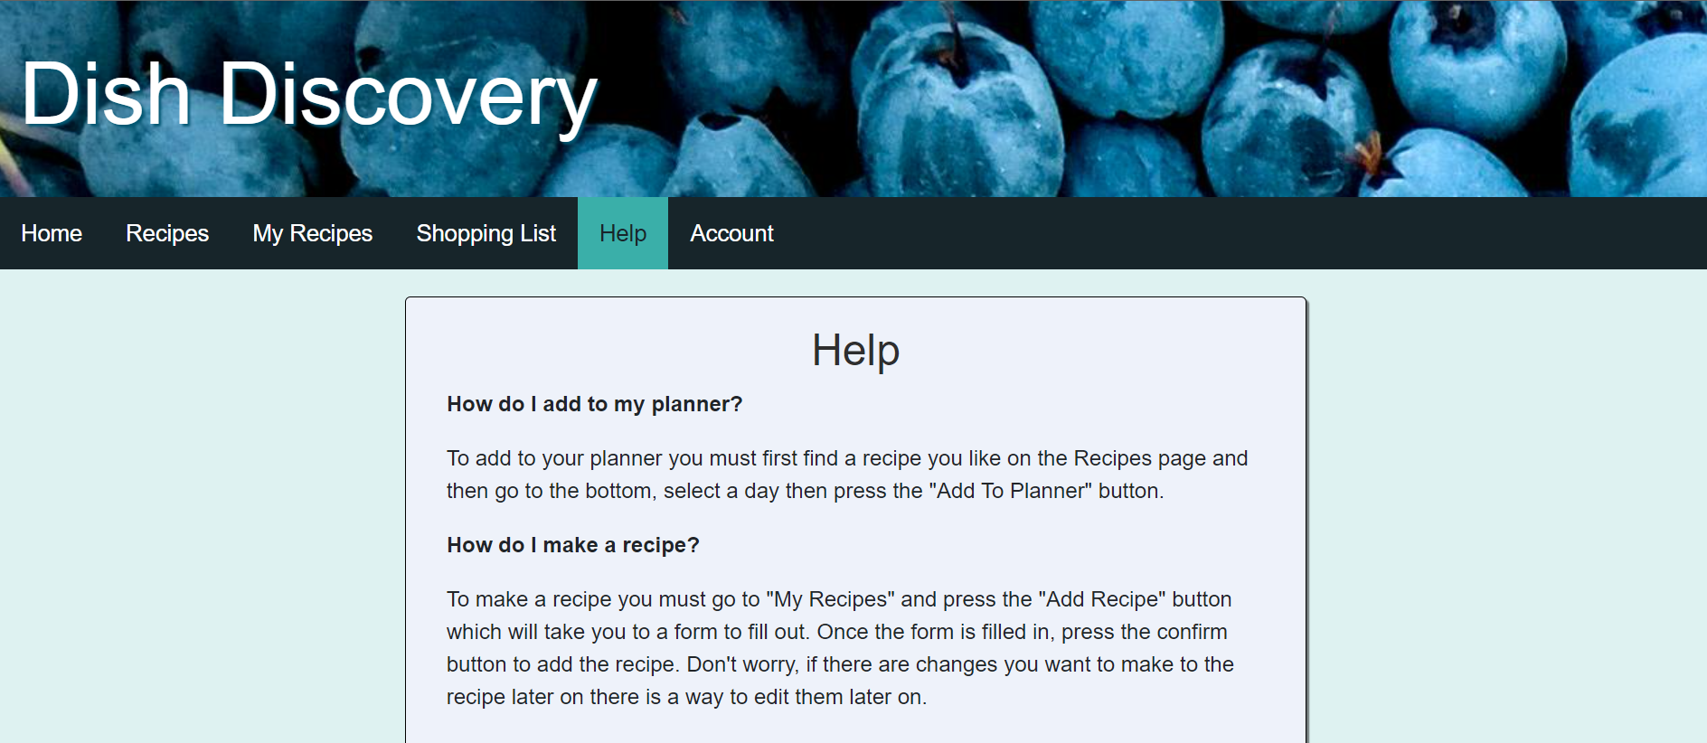

Figure 73. Help page.

### My Account Page

The “my account” page allows the user to change their password. It requires the user to put the password in twice to make sure that the passwords match before checking if they are valid. Once the similarity check is completed, a check is made using regular expressions to check the formatting of the password before submitting it to be changed on the server side. The password is also checked again on the server side before storing it in the users table. The account page has changed from the prototype with the delete account function being removed as there were some issues when it came to deleting users and the data linked to them.

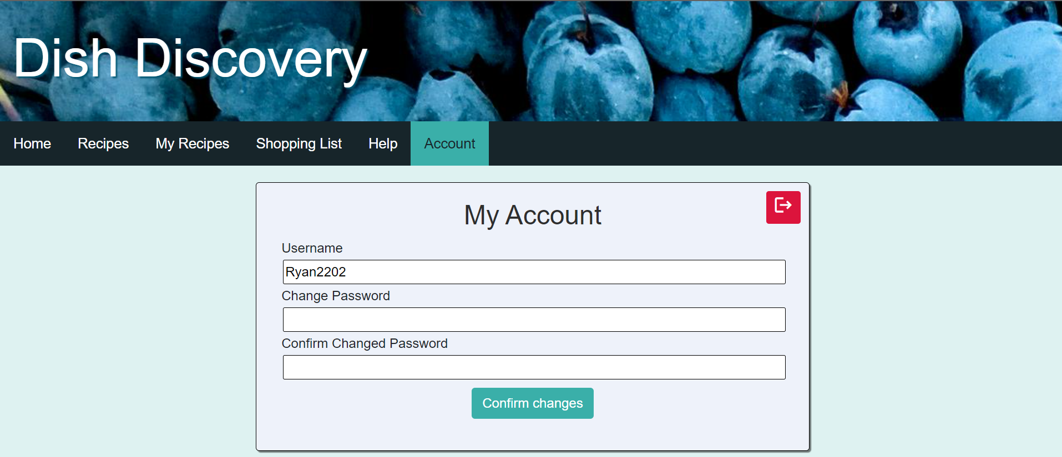

Figure 74. My account page.

### Selected recipe Page

The selected recipe has stayed consistently the same throughout the design and implementation stages as its use is to display a recipe in the clearest way possible. The only change is how recipes are added to the planner which originally was going to be a pop up but now is just a drop down select menu to select which day the user wants to add the recipe to.

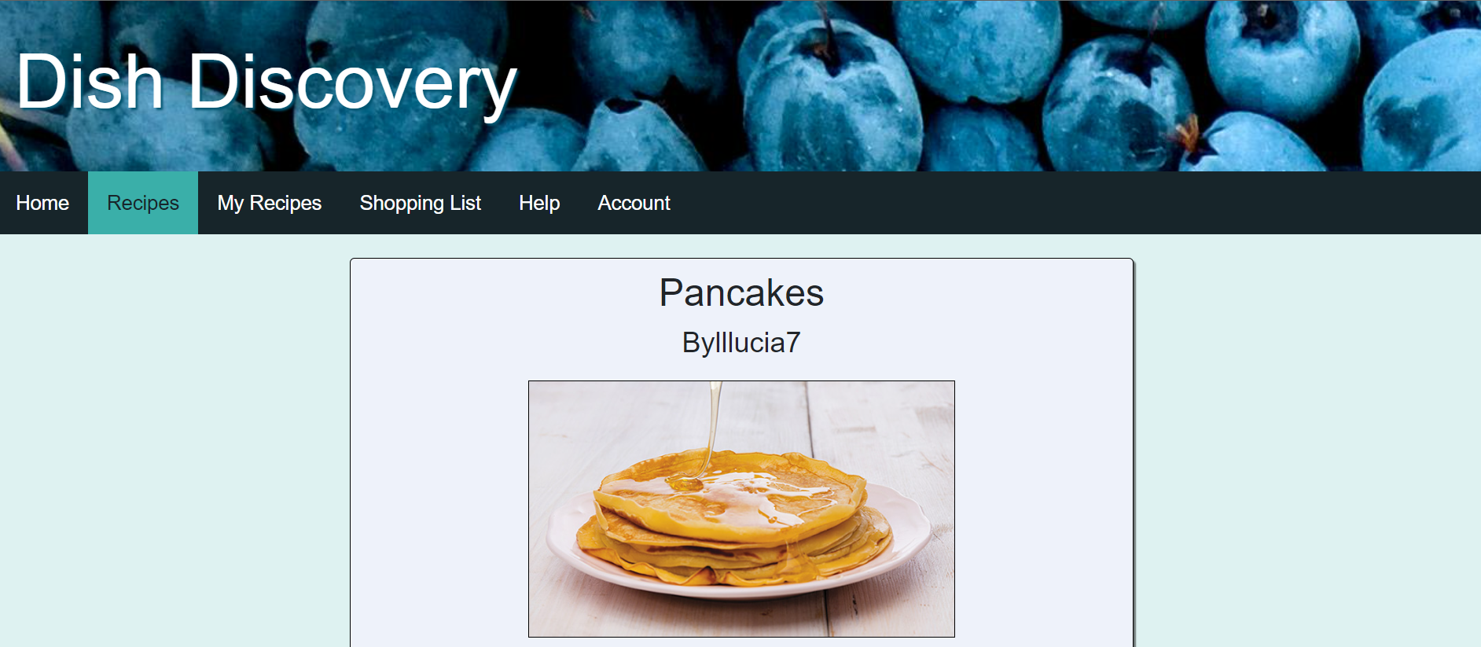

Figure 75. Selected recipe page 1.

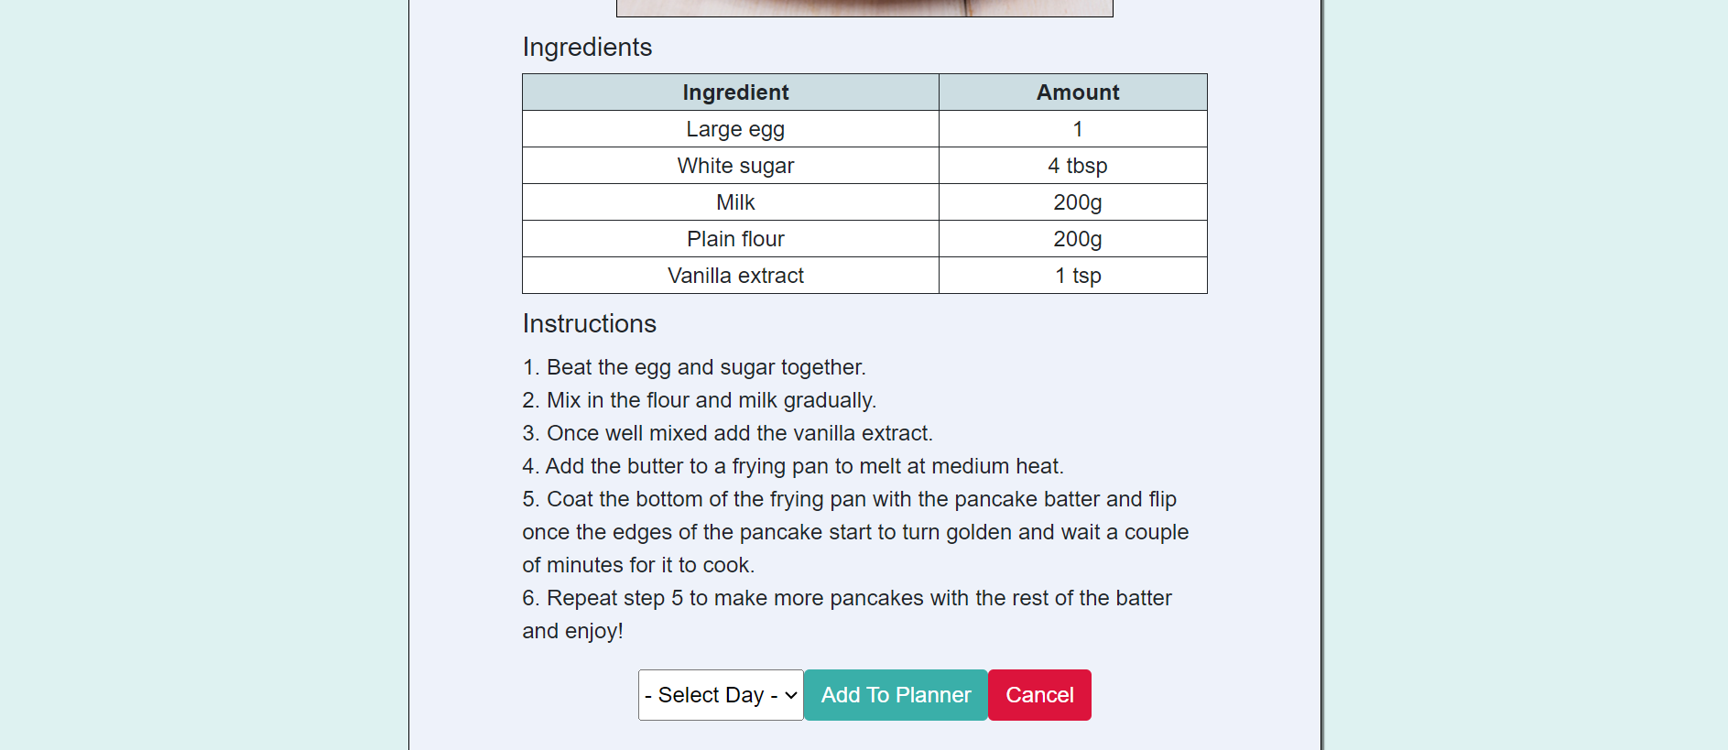

Figure 76. Selected recipe page 2.

### Add Recipe Page

The add recipe page is also very similar to the prototype with having all of the inputs to make a full recipe. The recipe is checked and prepared to be sent to be stored in the database in the JavaScript. To send the data to the PHP to store it in the database, it used fetch to send the data and then uses the response to tell the user if it is successful or not.

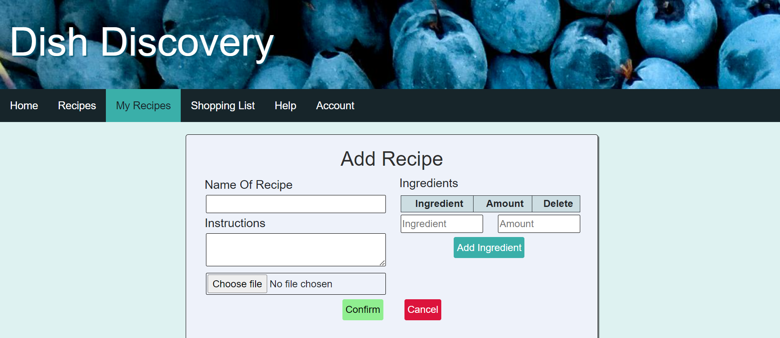

Figure 77. Add recipe page.

### Edit Recipe Page

The edit recipe is very similar to the add recipe but instead of having blank forms, the recipe is already put in there to make it easier for users to change the information.

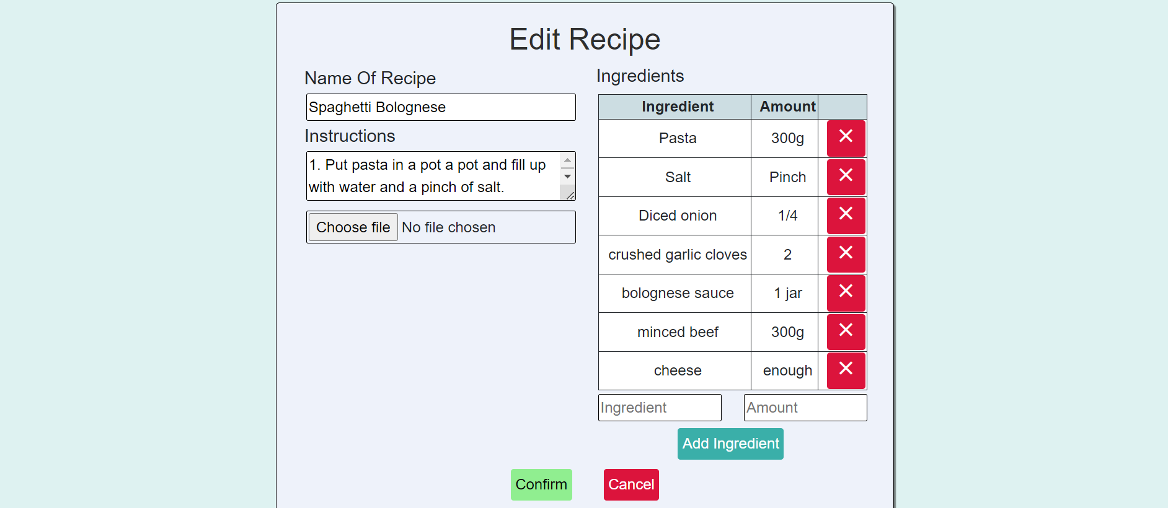

Figure 78. Edit recipe page.

### Administrator Page

The administrator page has not been changed from the prototype because the columns display all the information that it needs to. The design has been improved in the implementation by adding more colour and better-looking buttons to change the password and log out. The log out button is now an icon to avoid any overlapping of the header and the button on a mobile device. The reason that the page does not display the users passwords is because it would mean that the admin would have access to other users’ accounts. Instead, it requires the admin to change the password and it is advised that the user changes their password as soon as they can.

The password change is similar to the process of creating an account with the password being hashed and then stored in the database to add a level of encryption.

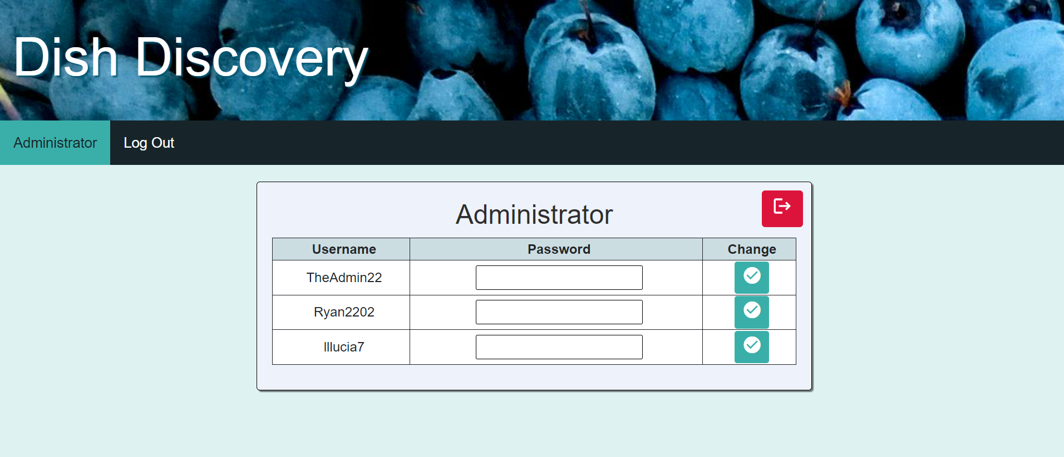

Figure 79. Admin page.

# Testing

The testing was carried out manually and had a very strict pass criteria that would be used to make sure each of the use cases were working correctly to handle valid and invalid data correctly if necessary. Images of the tests can be found in Appendix B.

Each of the use cases had multiple tests to ensure that the error handling and validation of the data being inputted works correctly. The aim was to ensure that every possibility was covered to avoid any issues when the customer uses the site.

## Test Table

|  |  |  |  |  |  |
| --- | --- | --- | --- | --- | --- |
| TEST REF | Use case | Test content | Pass Criteria | Test Result | Explanation |
| TR1.1 | Create Account | A valid input with key. | The details will allow the user to create an account. | PASS | Using login info that was valid created an account. |
| TR1.2 | Create Account | Valid username with an invalid password. | A message will appear saying that the username or password is in the incorrect format. | PASS | Message stating that the password or username is in the correct format appears. |
| TR1.3 | Create Account | An invalid username with a valid password. | A message will appear saying that the username or password is in the incorrect format. | PASS | Message stating that the password or username is in the correct format appears. |
| TR1.4 | Create Account | A valid username and password but with an incorrect key. | A message will appear that the key is incorrect. | PASS | A message appears saying that the user can get the key from a friend or family member already on the site. |
| TR1.5 | Create Account | A valid username and password but with no key. | A message will appear that the key is missing. | PASS | A message appears saying that the user can get the key from a friend or family member already on the site. |
| TR1.6 | Create Account | Create an account with exisiting username. | A message will appear stating user already exists. | PASS | A message appears stating the user already exists. |
| TR2.1 | Log In | Use correct password and username to log in. | The details will allow the user to log in. | PASS | When details are correct, account is logged in and goes straight to the planner page. |
| TR2.2 | Log In | Use correct username but incorrect password. | A message will appear saying that the username or password is incorrect. | PASS | When the username is correct and the password is not, a message will appear to say that the username or password is incorrect. |
| TR2.3 | Log In | Use incorrect username but correct password. | A message will appear saying that the username or password is incorrect. | PASS | A message appears saying that the login was unsuccessful if the details are in the correct format but are not correct. |
| TR3.1 | Add Recipe | A full recipe will be entered with valid data. | A recipe should be added with the correct information. | PASS | Recipe is successfully created. |
| TR3.2 | Add Recipe | No data will be added. | A recipe should not be added due to the form being blank. | PASS | An alert notifying the user that the recipe name or instructions is blank will appear. |
| TR3.3 | Add Recipe | A valid recipe will be added without an image. | A recipe should not be added if there is no image. | PASS | An alert notifying the user that there is no image appears. |
| TR3.4 | Add Recipe - Add Ingredient | Add ingredient with both fields filled in. | An ingredient will be added to the list. | PASS | An ingredient is added to the list. |
| TR3.5 | Add Recipe - Add Ingredient | Add ingredient to field with no amount. | An ingredient will not be added if the ingredient is blank. | PASS | If the ingredient is missing the ingredient will not be added to the list. |
| TR3.6 | Add Recipe - Add Ingredient | Add amount to field with no ingredient. | An amount will not be added if the ingredient is blank. | PASS | If the amount is missing the ingredient will not be added. |
| TR4.1 | Edit Recipe | All valid recipe data. | A recipe should be successfully updated with new, valid data. | PASS | Recipe successfully updated. |
| TR4.2 | Edit Recipe | All valid recipe data with no image. | A recipe should be successfully updated if there is no image. | PASS | Recipe successfully updated with no image. |
| TR4.3 | Edit Recipe | Recipe with a recipe name with invalid characters. | A recipe should not be successfully updated if the recipe name is invalid. | PASS | Recipe name was given some forbidden characters e.g. a full stop and it gave an alert. |
| TR4.4 | Edit Recipe | recipe with instructions with invalid characters. | A recipe should not successfully be updated if the instructions is invalid. | PASS | Instructions were given forbidden characters e.g. <>. |
| TR4.5 | Edit Recipe - Add Ingredient | Add ingredient with both fields filled in. | An ingredient will be added to the list. | PASS | An ingredient is added to the list. |
| TR4.6 | Edit Recipe - Add Ingredient | Add ingredient to field with no amount. | An ingredient will not be added if the ingredient is blank. | PASS | If the ingredient is missing the ingredient will not be added to the list. |
| TR4.7 | Edit Recipe - Add Ingredient | Add amount to field with no ingredient. | An amount will not be added if the ingredient is blank. | PASS | If the amount is missing the ingredient will not be added. |
| TR5.1 | Remove Recipe | Remove recipe in my recipes page. | A recipe created by that user can be removed. | PASS | Recipe removed. |
| TR5.2 | Remove Recipe | Remove recipe in my recipes page. | A recipe that is added to a planner can be removed. | PASS | Recipe removed even though it was added to a planner. |
| TR6.1 | Shopping List | Click on shopping list page. | When clicking on the shopping list tab, all ingredients are shown for the recipes in the planner. | PASS | Shopping list appears with all ingredients needed for the recipes in the planner. |
| TR7.1 | Add To Planner | Go on a selected recipe and scroll to the bottom. Add it to Monday. Press add to planner. | When viewing a recipe, selecting a day and pressing the button will add the recipe to that day of the week. | PASS | Recipe successfully added to the planner after selecting the recipe and adding it to a day of the week. |
| TR8.1 | Remove From Planner | On the planner page, press the remove button for a day with a recipe in it. | Pressing the remove button on the side of the recipe in the planner will remove the recipe from the planner. | PASS | A recipe was successfully removed from the planner. |
| TR9.1 | Log Out (Admin) | Press the log out button. | The user will be logged out. | PASS | Admin was logged out. |
| TR9.2 | Log Out (Regular) | On the account page, click the log out button. | The user will be logged out. | PASS | User was logged out. |
| TR10.1 | Change Password (Admin) | Change the password for a user with a valid password. | Password will be changed. | PASS | Password was changed. |
| TR10.2 | Change Password (Admin) | Change the password for a user with an invalid password. | Password will not be changed if it is not valid. | PASS | If the password is not valid, it will not change. |
| TR10.3 | Change Password (Admin) | Change the password with no password in the field. | Password will not be changed if it is empty. | PASS | Password will not change if the form is empty. |
| TR11.1 | Change Password (Regular) | Enter a password into both of the fields to confirm the password. | Password will be changed. | PASS | User password was changed. |
| TR11.2 | Change Password (Regular) | A password that is not valid will be entered into the fields. | Password will not be changed if it is not valid. | PASS | An alert appears to tell the user that the passwords are in the incorrect format. |
| TR11.3 | Change Password (Regular) | No password will be entered into either box. | Password will not be changed if it is empty. | PASS | If both of the boxes are empty, an alert will appear to say what is expected when creating a new password. |
| TR11.4 | Change Password (Regular) | One field will contain a valid password and one will be empty. | Password will not be changed if one field is empty. | PASS | If one box is empty and the other contains a valid password, an alert will appear to say that the passwords do not match. |
| TR11.5 | Change Password (Regular) | The new password field and the confirm new password will contain different passwords but will be valid. | Password will not be changed if the passwords do not match. | PASS | If the passwords are valid but are not the same, an alert will appear to say they don’t match. |
| TR12.1 | Browse Recipes | Go to the recipes page and scroll through to see all recipes. | Can view all recipes. | PASS | All recipes are visible when on the recipes page. |
| TR12.2 | Browse Recipes - Search | Use the search bar to search Ryan2202. | The recipes made by Ryan2202 will display. | PASS | All recipes made by Ryan2202 appeared. |
| TR12.3 | Browse Recipes - Search | Use the search bar to search pasta. | All recipes that contain the word pasta in the recipe name will display. | PASS | All recipes containing pasta appeared. |
| TR12.4 | Browse My Recipes | Go to my recipes page and scroll through the recipes table. | Can view all recipes made by the logged in user. | PASS | All recipes created by the logged user are visible. |
| TR13.1 | View Recipe | Go to the planner page and click on the desired recipe. | Recipe can be viewed from planner. | PASS | Recipe can be viewed by clicking on a recipe in the planner. |
| TR13.2 | View Recipe | Go to the recipes page and scroll through to see all recipes. | Recipe can be viewed from recipes. | PASS | Recipe can be viewed by clicking on a recipe in the recipes page. |
| TR13.3 | View Recipe | Go to the “my recipes” page and scroll through to see all recipes made by the signed in user. | Recipe can be viewed from my recipes. | PASS | Recipe can be viewed by clicking on a recipe in the “my recipes” page. |

## User Testing And Feedback

This is the feedback from the client with an explanation of what they thought of how the use cases were implemented. I have asked 5 people who gave feedback on the prototype to create an account and give feedback about what they think about the use cases now they are on a real site.

|  |  |  |
| --- | --- | --- |
| Use Case | Rating /5 | Explanation |
| Create Account | 4 | Creating an account was very easy and straight forward. |
| Log In | 5 | Logging in was also very easy and quick to do. |
| Create Recipe | 4 | Very easy to create and the boxes where each part of the recipes goes makes it easy to read and find what we've already wrote. |
| Edit Recipe | 5 | The edit recipe button was found with ease. Editing the recipe was equally simple to do. |
| Remove Recipe | 5 | Easy to find remove button and to remove recipe. |
| Make Shopping List | 3 | Accessing the shopping list was straight forward. However, it would be nice to be able to leave and go back to the shopping list page without the page resetting and deleted items coming back. Also, it would be useful if it was possible to add additional ingredients to the shopping list that aren't included in the recipes. |
| Add To Planner | 5 | Adding recipes to the weekly planner is nice and easy as it is included at the bottom of every recipe and has the days we can select from. |
| Remove From Planner | 5 | Easy to find remove button and remove. |
| Browse My Recipes | 5 | Easy to browse, page is very clear and readable. |
| Browse Recipes | 5 | Easy to browse, page is very clear and readable. |
| Change Password | 5 | Account page was found with ease and the box to change my password was very clear. |

|  |  |  |
| --- | --- | --- |
| Use Case | Rating /5 | Explanation |
| Create Account | 4 | Creating an account was simple but needed more information about the key. |
| Log In | 5 | Login was simple. Worked with Password auto filling. |
| Create Recipe | 4 | Was easy to create but the instructions box is a bit small. |
| Edit Recipe | 5 | Easy to follow. |
| Remove Recipe | 5 | Removing recipe was easy but search feature would be nice on my recipes page. |
| Make Shopping List | 3 | Good to see all recipes' ingredients on one page to use as a shopping list but it doesn’t save any changes. Would be nice to add more items if needed. |
| Add To Planner | 5 | Easily accessible. |
| Remove From Planner | 5 | Simple button removes recipe easily. |
| Browse My Recipes | 5 | Simple look and everything is easy to find. |
| Browse Recipes | 5 | Easy to look at all of the recipes and helps that there is a search feature. |
| Change Password | 5 | Clear and efficient. |

|  |  |  |
| --- | --- | --- |
| Use Case | Rating /5 | Explanation |
| Create Account | 5 | Simple and easy. |
| Log In | 5 | Login was good. Easy to follow. |
| Create Recipe | 5 | Page looks good on mobile. |
| Edit Recipe | 5 | Same as create recipe, looks good and easy to do. |
| Remove Recipe | 5 | Easy to do. |
| Make Shopping List | 4 | Looks good but buttons are on top of each other on mobile. |
| Add To Planner | 4 | Easy to use but needs an explanation on where to find it. |
| Remove From Planner | 5 | Easy to do. |
| Browse My Recipes | 5 | Neat presentation. |
| Browse Recipes | 5 | Neat presentation and search bar is helpful. |
| Change Password | 5 | Easy to do. |

|  |  |  |
| --- | --- | --- |
| Use Case | Rating /5 | Explanation |
| Create Account | 4 | Intuitive to use but requires the user to know the key. |
| Log In | 5 | Easy to use |
| Create Recipe | 5 | Very use to use right from the start. |
| Edit Recipe | 5 | Found this very useful for correcting a mistake |
| Remove Recipe | 5 | Simple action |
| Make Shopping List | 5 | Page looks goods and provides useful feature |
| Add To Planner | 4 | Not super clear that it was added |
| Remove From Planner | 5 | Easy action to perform. |
| Browse My Recipes | 5 | Clear presentation with no faults |
| Browse Recipes | 5 | Really appreciated the search bar |
| Change Password | 5 | Useful and easy to do. |

|  |  |  |
| --- | --- | --- |
| Use Case | Rating /5 | Explanation |
| Create Account | 5 | Creating an account was very straight forward to do. |
| Log In | 5 | Logging in was also very straight forward as the logging in boxes for username and password were easily identifiable. |
| Create Recipe | 5 | It was easy to find the page and button to create new recipes. Creating the new recipe was equally as easy as the boxes were easy to find and select. I liked the table with the ingredients a lot as it makes all ingredients and quantities very clear. |
| Edit Recipe | 5 | The page and button to edit recipes were very easy to find. Changing the recipe was also good as I could select the part of the instructions I wanted to change and delete or add more ingredients. |
| Remove Recipe | 5 | The remove button was very clear and removing the recipe was easy to do. |
| Make Shopping List | 4 | It was easy to find and access the shopping list. I liked how recipes' ingredients are added to the shopping list, but it would be good if it was possible to leave the shopping list page and go back without the ingredient list resetting after certain ingredients were deleted. |
| Add To Planner | 5 | I liked how the bottom of every recipe has the option to add it to the weekly planner. I found this extremely easy to find and do. |
| Remove From Planner | 5 | The remove button was clear and removing recipes from planner was easy. |
| Browse My Recipes | 5 | It was easy to browse recipes I have created as the page had a clear presentation with the way my recipes were presented. |
| Browse Recipes | 5 | It was easy to browse recipes me and other people have created as the page presented recipes clearly with pictures, titles and included who wrote each recipe. |
| Change Password | 5 | Change password was easy to do as the account page was clear. |

# Critical Evaluation

Overall, I am very happy with the final product that I have created. I am especially happy the functionality and handling of the persistent data of the site as this was one of my main worries before starting the project. I believe that my success with the project was down to having a good plan and design for both the look and persistent data side of the site. There are some things I wish I did differently, and this includes adding some of the code to functions to avoid functions being almost the same but with some small changes.

## The Design

I am happy with my design because it is simple and met all the use cases that was needed in the site but there are some changes that I would have made to the design stage. The changes that I would have made are to the functions that I have used and planned out what functions would be needed and what they would look like to reduce the amount of code that is reused, for example, getting the response from the PHP files that involved the same “if(response.success)…” statement. This was used many times but could have been reduced to a single function that is called multiple times.

On the overall look of the site, I would have liked to have more colour and pictures to make it more visually pleasing for the user. This was given in some feedback from users with the prototype, and this is where the image in the header was added. My thought at the time for not adding more images was that the site would primarily be used on a mobile device and would remove the needed for more images. The decision to have less images was due to other similar sites having crowded sites and it made it difficult to navigate or find anything specific.

## Choice Of Tools Used

Overall, I am happy with the choice of the tools that I used but I feel that I could have used more to make the implementation process more streamlined. A framework that helped a lot when it came to the responsiveness of the site was Bootstrap. It removed the need for using media queries as Bootstrap had classes to change the size of items based on screen size and meant that my CSS files would not be too large. It also helped with the looks of some of the features such as the buttons and the cards as they had a neat, uniform look to them (Bootstrap, 2024).

The IDE that I used to complete this project is IntelliJ as it provided me with a way to create and view the tables needed for this project, furthermore, it had a console to be able to execute queries to test the queries that I needed to get the correct data. This proved to be very useful and removed the need for another application such as pgAdmin (Postgres, 2024).

Tools that I could have used include Express as it is in a language I am familiar with but having more time to learn these frameworks would have made them easier to use and make the code more streamlined. Express would have helped with error handling and database handling with PostgreSQL in JavaScript instead of using as many PHP files as I did (Express Js, 2024).

## What I Would Do Differently

If I was given the change to do the project again, I would think more about the look and navigation of the site to make sure that there was more freedom of where the use cases could be completed, for example, creating a new recipe would be available on any page that required the user to look at and select recipes.

Another thing I would do differently is to use more frameworks to make the implementation process easier by relying on some of the functions that are readily available in the frameworks. To add these new frameworks, I would have liked more time to learn how to use these frameworks to get a good understanding of how they work to be able to use them effectively.

The final thing I would change is the fact that the administrator only has access to the admin page and it would be good for the admin to have the ability to also add and remove recipes that are their own and by any other use in the case that the recipe had issues that the user didn’t care to change for any reason. As well as this I would also add the ability to remove accounts if necessary. These were not originally implemented as there were some difficulties with deleting users as they were referenced in other tables and the ability for admins to create, edit or remove recipes were not thought about until the later stages of the implementation.

What I would do the same would be keeping the same theme of the site as it is something I am passionate about. I would also not change how the data is stored in the database and how the data is managed because all the information is displayed correctly and gives the user the information they are looking for.

Another thing that I would do the same is the Business Analysis, UI Design and Analysis and Technical design. I believe that I completed these to a good standard and it was a good foundation for the implementation. The only parts of these documents I would change would be the parts that were given some constructive feedback on, and this should be reflected in this report.

## Future Development

There are some features that were not added due to the length of this project that I would have like to have added and these will be added in a future release of the site. These include:

* Removing an account if the user or administrator wishes to.
* Adding items to the shopping list, A search function on the “My Recipes” page.
* Ending a session after a certain amount of time if left inactive.

Some features that I wish to add that were not part of the original use cases or design are:

* Being able to add extra recipes to the planner to allow for more freedom of recipes that could be used on the site, for example, if the user enjoys baking.
* Being able to follow or add other users to see only their recipes. This would allow for a larger audience instead of a small group.
* A comment and sharing system for the recipes.
* Blog and profiles for each user.

# References

BBC. (2024, February). *BBC Food*. Retrieved from BBC Food: https://www.bbc.co.uk/food

Bootstrap. (2024, April). *Build fast, responsive sites with Bootstrap*. Retrieved from Bootstrap: https://getbootstrap.com/

Bootstrap. (2024, April). *Licenses*. Retrieved from Bootstrap: https://getbootstrap.com/docs/4.1/about/license/

Budiu, R. (2021, July 11). *Why 5 Participants Are Okay in a Qualitative Study, but Not in a Quantitative One*. Retrieved from Nielsen Norman Group logoNielsen Norman Group: https://www.nngroup.com/articles/5-test-users-qual-quant/#:~:text=That%20the%20probability%20of%20someone,the%20issues%20in%20an%20interface.

Dotdash Meredith. (2024, February). *Allrecipes*. Retrieved from Allrecipes: https://www.allrecipes.com/

Dotdash Meredith. (2024, February). *Simply Recipes*. Retrieved from Simply Recipes: https://www.simplyrecipes.com/

Express Js. (2024, April). *Database Integration*. Retrieved from Express: https://expressjs.com/en/guide/database-integration.html#postgresql

Geeks For Geeks. (2024, April). *MVC Framework Introduction*. Retrieved from Geeks For Geeks: https://www.geeksforgeeks.org/mvc-framework-introduction/

Google. (2024, March). Retrieved from Google Fonts: https://fonts.google.com/icons

McGuire, M. (2024, March). *Top 4 software development methodologies*. Retrieved from Synopsys: https://www.synopsys.com/blogs/software-security/top-4-software-development-methodologies.html

Noble Desktop. (2024, April). *Setting the Viewport Meta Tag*. Retrieved from Noble Desktop: https://www.nobledesktop.com/learn/html-css/setting-the-viewport-meta-tag#:~:text=The%20viewport%20meta%20tag%20controls,and%20scaling%20on%20different%20devices.

Pexels. (2024, March). *Can I use the photos and videos for a commercial project?* Retrieved from Pexels: https://help.pexels.com/hc/en-us/articles/360042295214-Can-I-use-the-photos-and-videos-for-a-commercial-project#:~:text=Yes%2C%20all%20photos%20and%20videos,%2C%20product%2C%20or%20anywhere%20else.

PHP Group. (2024, April). *PHP*. Retrieved from PHP: https://www.php.net/

Postgres. (2024, April). *pgAdmin*. Retrieved from pgAdmin: https://www.pgadmin.org/

PostgreSQL. (2024, April). *License*. Retrieved from PostgreSQL: https://www.postgresql.org/about/licence/

PostgreSQL. (2024, April). *PostgreSQL: The World's Most Advanced Open Source Relational Database*. Retrieved from PostgreSQL: https://www.postgresql.org/

Relish. (2024, February). *Relish*. Retrieved from Relish: https://www.relish.com/app/

Stack Overflow. (2024, March). *Redirection through json_encode in php*. Retrieved from Stack Overflow: https://stackoverflow.com/questions/42725089/redirection-through-json-encode-in-php

W3 Schools. (2024, April). *SQL CASE Expression*. Retrieved from W3 Shcools: https://www.w3schools.com/sql/sql_case.asp

# Appendices

## Appendix A – Design Questionnaire

1. **On the landing page, how easy was it to find out where you had to log in/register?**

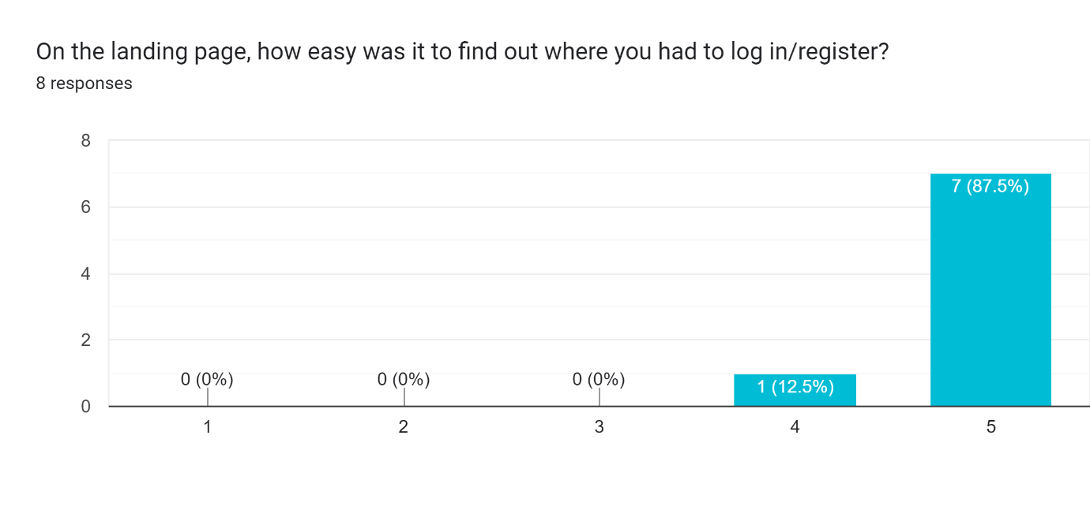

1. **Is there anything that could be improved on the landing page to make it more clear?**

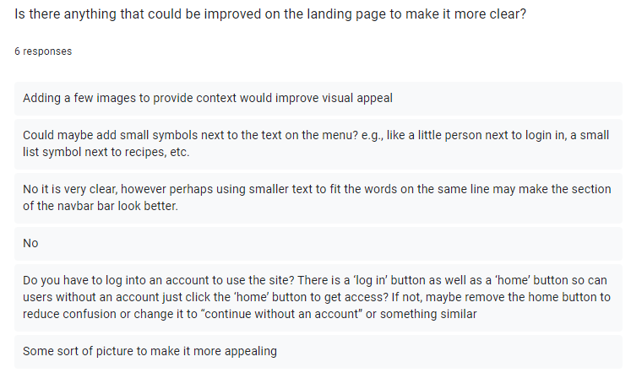

1. **How simple is it to log in/register to access the site?**

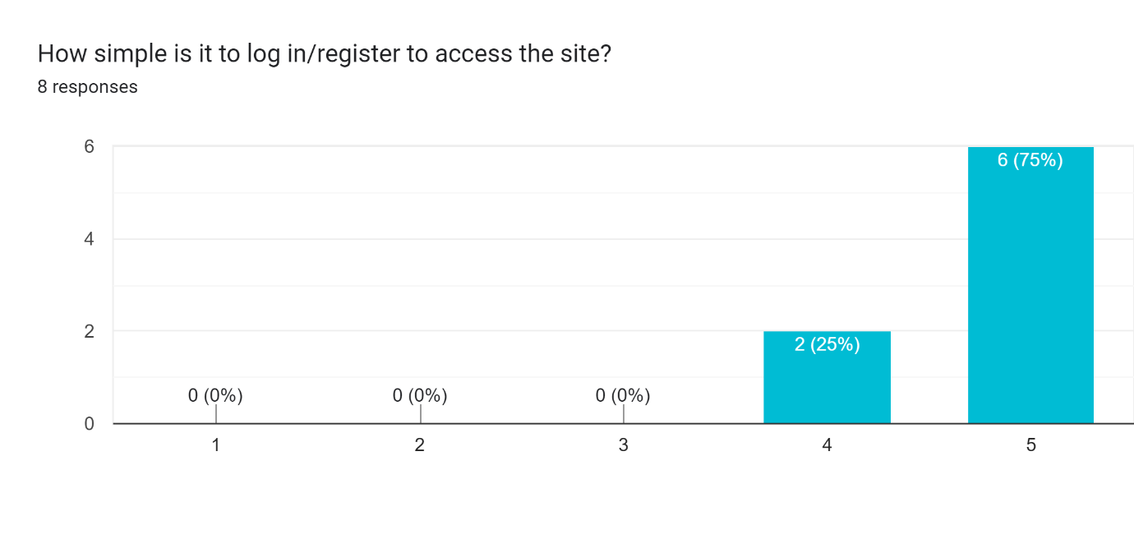

1. **Are there any improvements that you would like to see regarding the login page?**

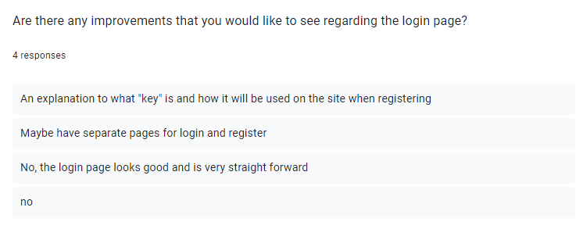

1. **List the pages you would go through to get to a recipe?**

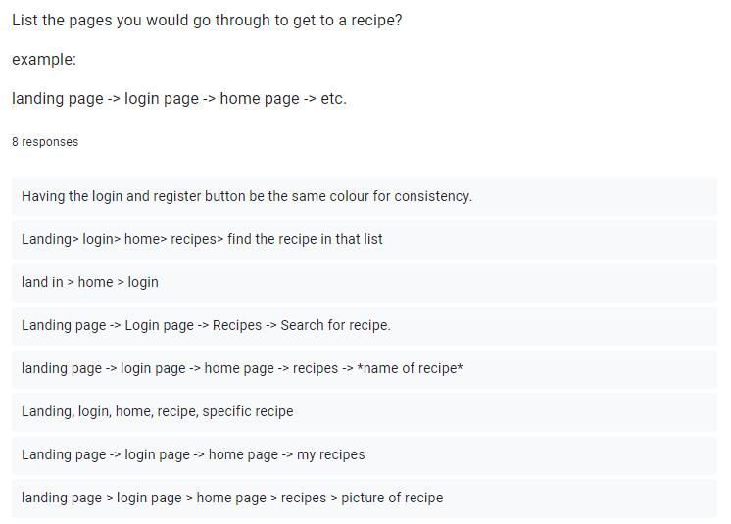

1. **How easy is it to find the recipe that you want to view?**

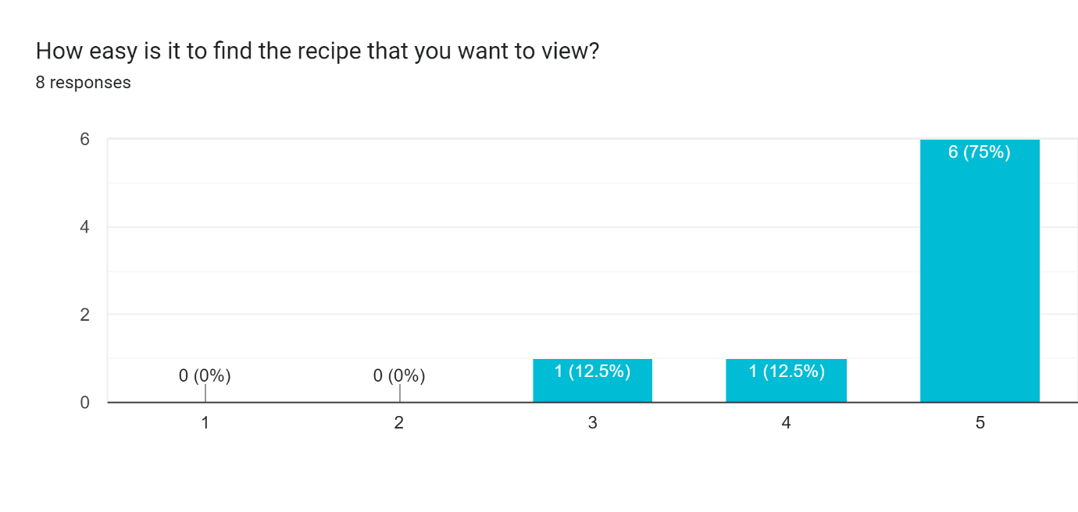

1. **How clear and/or easy to follow are the recipes? (question on formatting of the page)**

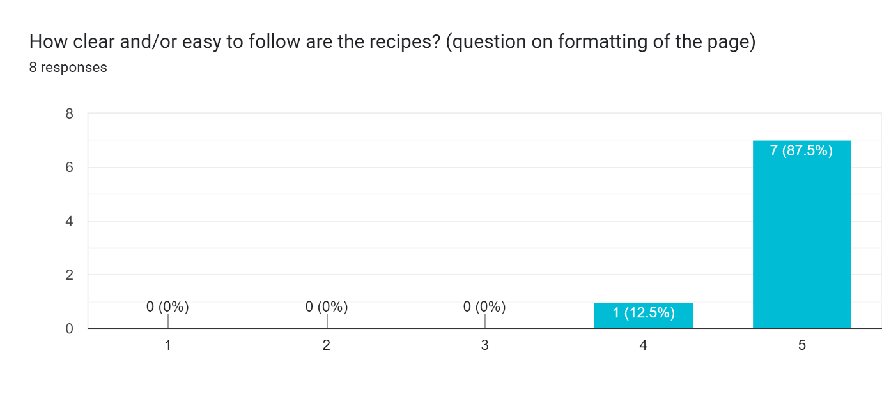

1. **What could be improved with the recipe system?**

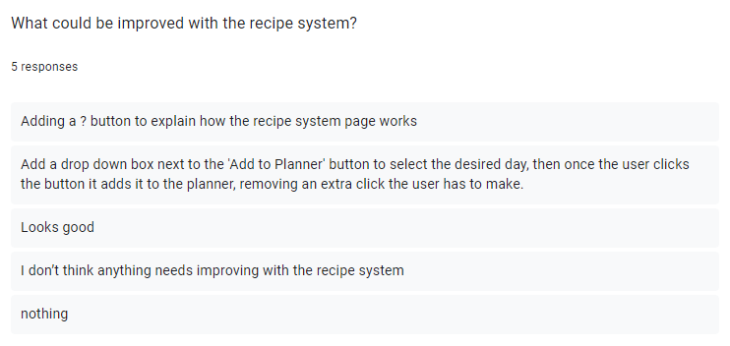

1. **What pages would you go through to see your shopping list?**

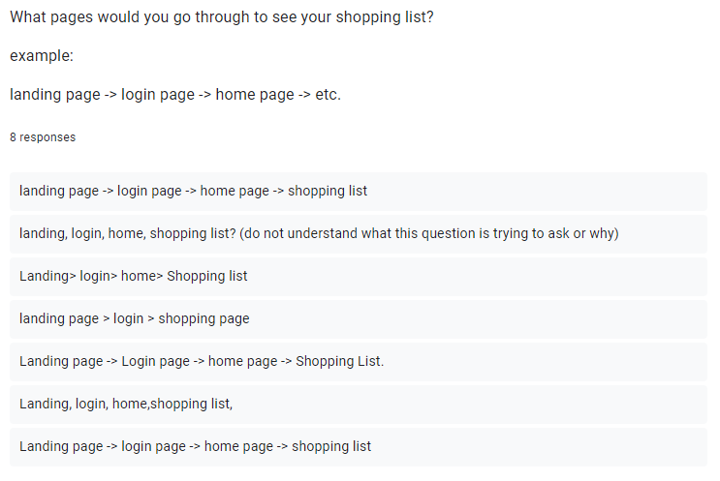

1. **How easy is it to view the shopping list?**

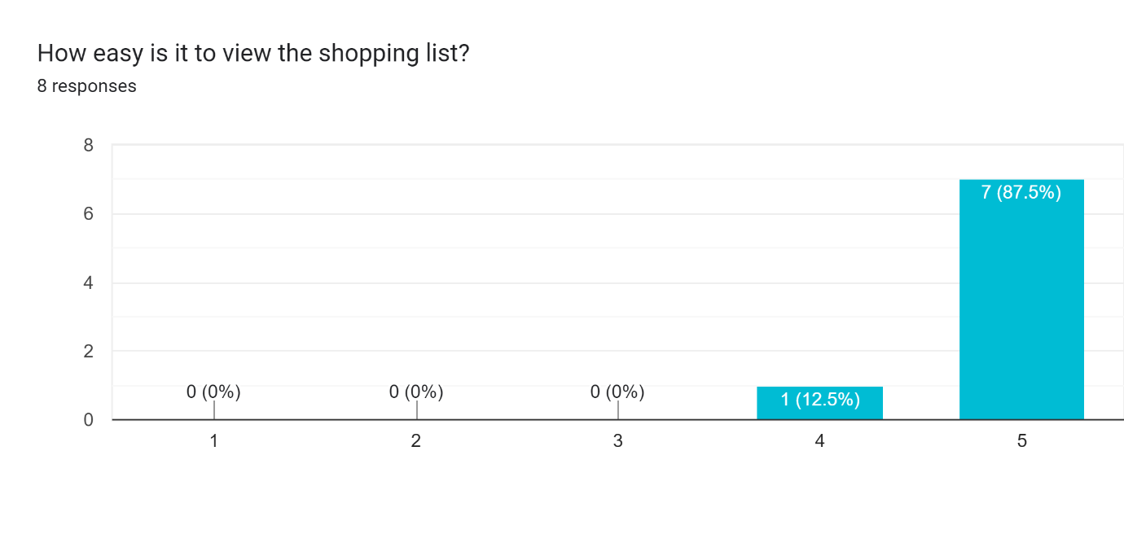

1. **How easy is the shopping list to follow?**

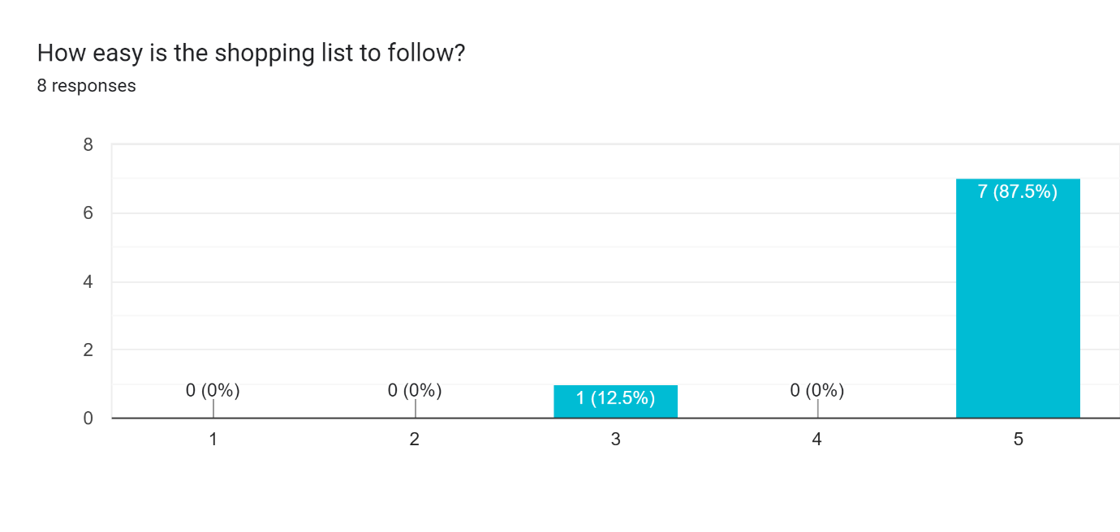

1. **What would you improve about the shopping list feature?**

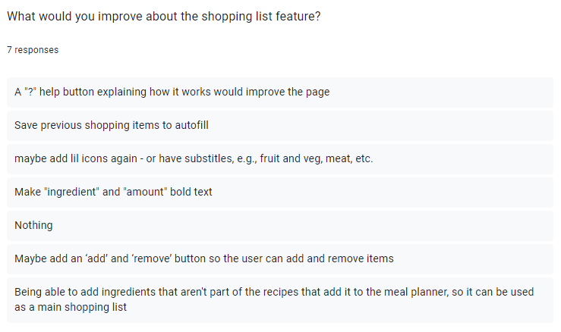

1. **How easy is it to create a recipe?**

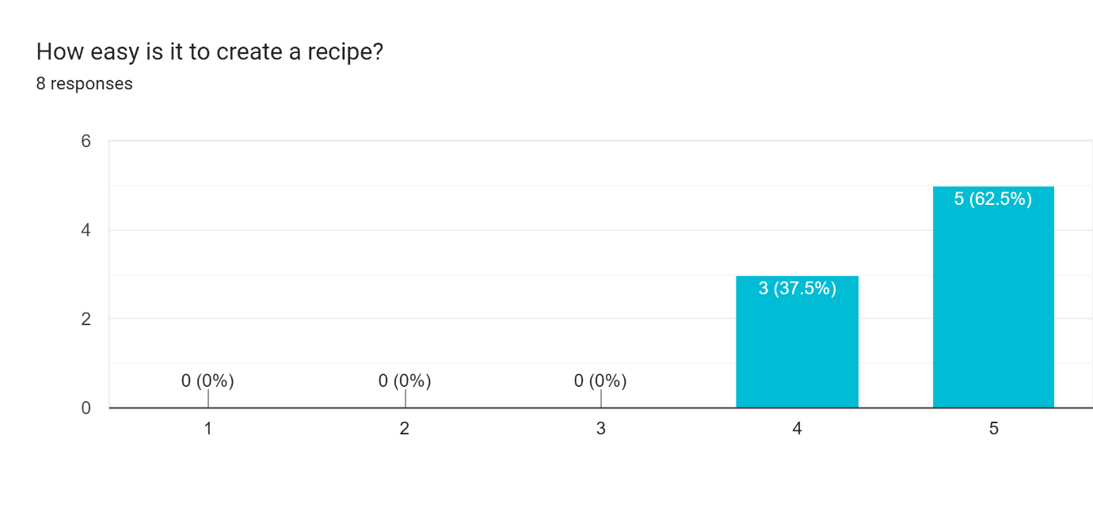

1. **What could be improved about creating a recipe?**

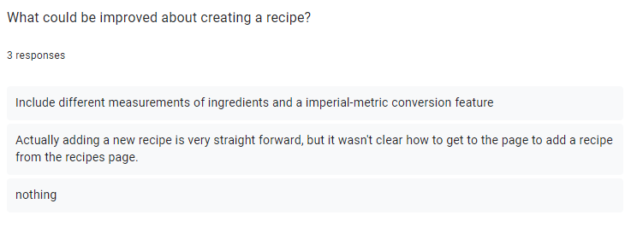

1. **What improvements not already mentioned that you would like to see that could be implemented into the final product?**

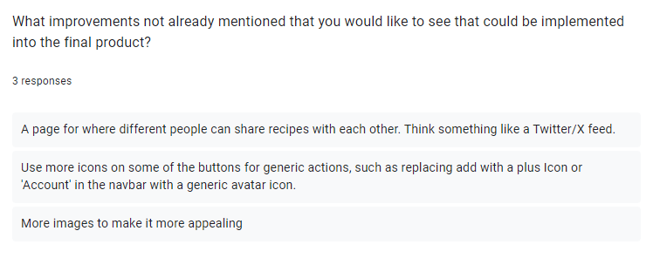

## Appendix B – Test Table Images

|  |  |
| --- | --- |
| TEST REF | Images |
| TR1.2 |  |
| TR1.3 |  |
| TR1.4 |  |
| TR1.5 |  |
| TR1.6 |  |
| TR2.3 |  |
| TR3.1 |  |
| TR3.2 |  |
| TR3.3 |  |
| TR3.5 |  |
| TR3.6 |  |
| TR4.1 |  |
| TR4.2 |  |
| TR4.5 |  |
| TR4.6 |  |
| TR4.7 |  |
| TR6.1 |  |
| TR7.1 |  |
| TR8.1 |  |
| TR10.2 |  |
| TR10.3 |  |
| TR11.1 |  |
| TR11.2 |  |
| TR11.3 |  |
| TR11.4 |  |
| TR12.2 |  |
| TR12.3 |  |

## Appendix C – Original Prototype

|  |  |
| --- | --- |
| Page | Page Design |
| Landing Page |  |
| Landing Page Nav |  |
| Login Page |  |
| Home Page |  |
| Home Page Nav |  |
| Recipes Page |  |
| My recipes Page |  |
| Shopping List Page |  |
| Account Page |  |
| Add Recipe Page |  |
| Edit Recipe Page |  |
| Selected Recipe Page |  |
| Admin Page |  |

## Appendix D – Ethical Clearance Confirmation

